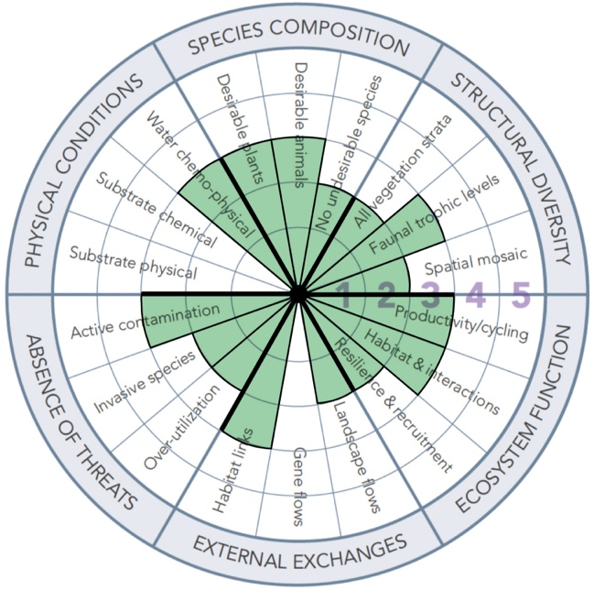 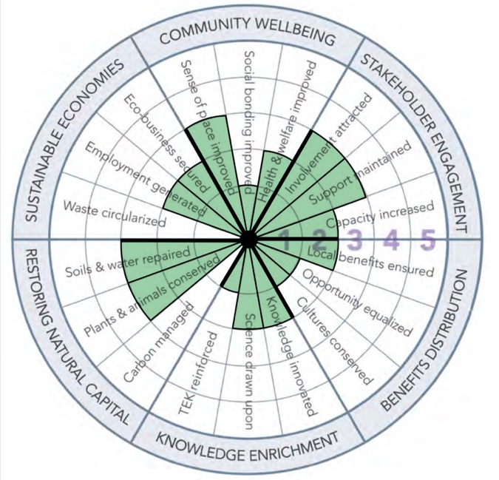

**Figure 2.1.** Society for Ecological Restoration (SER) restoration wheel and social benefits wheel completed for the Mill Creek Subwatershed.

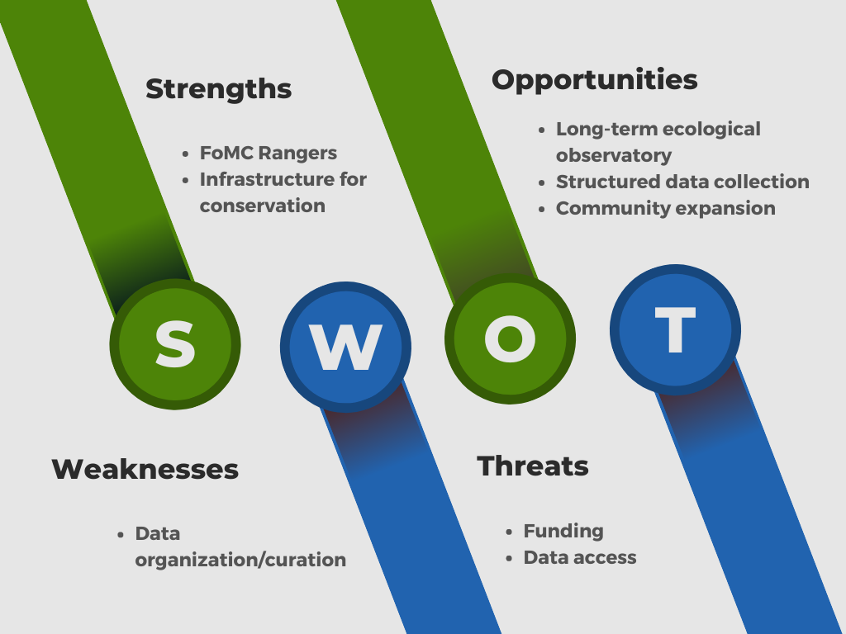

**Figure 2.2.** SWOT Analysis of the Friends of Mill Creek (FoMC) organization. This SWOT analysis identifies the major strengths, weaknesses, opportunities and threats brought to the table by FoMC since they were first founded.

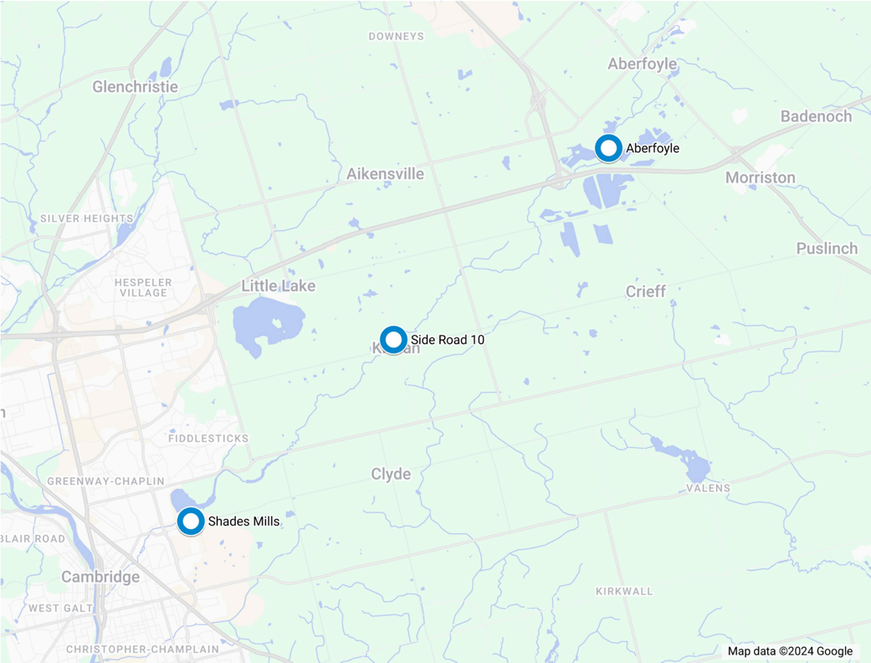

**Figure 4.1.1.** Location of continuous gauge stations and climate stations on Mill Creek (GRCA, n.d.b).

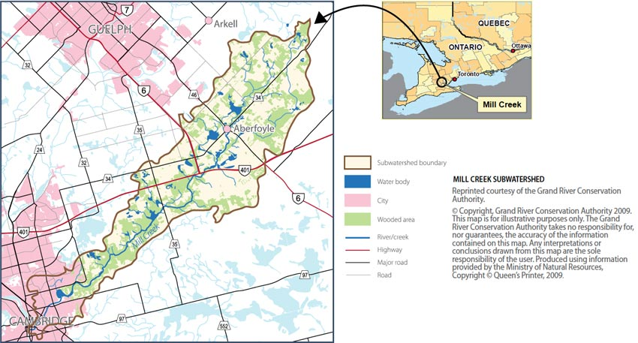  
**Figure 5.1**. Mill Creek Subwatershed map (Friends of Mill Creek, n.d.)

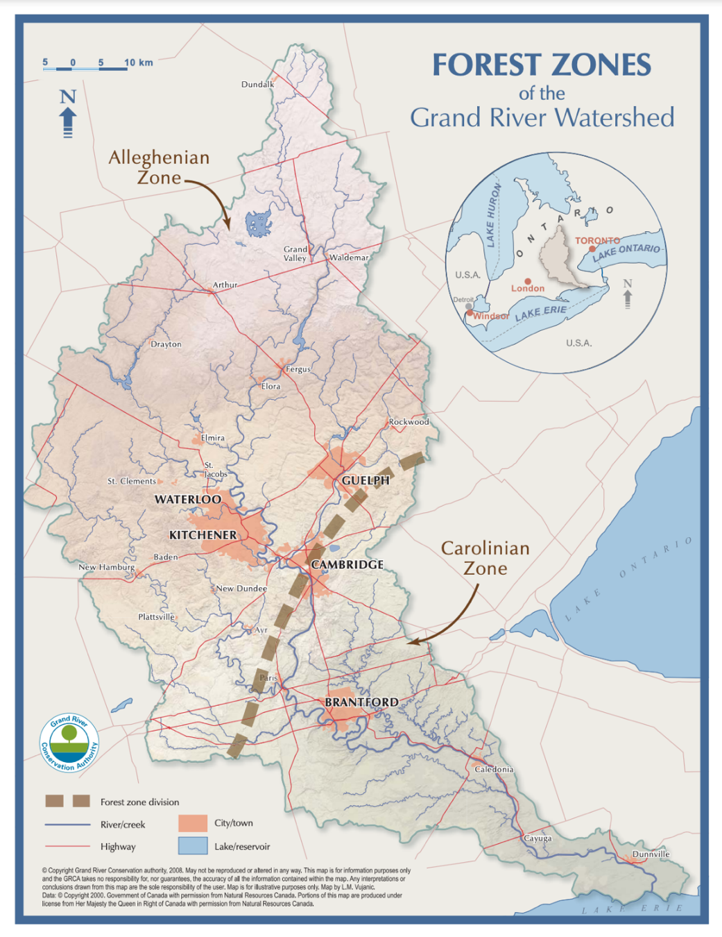

**Figure 5.5.1.** Forest zones of the Grand River Watershed, showing Mill Creek just south of the boundary between the Alleghenian Zone and Carolinian Zone (GRCA, n.d.d; GRIN, n.d.).

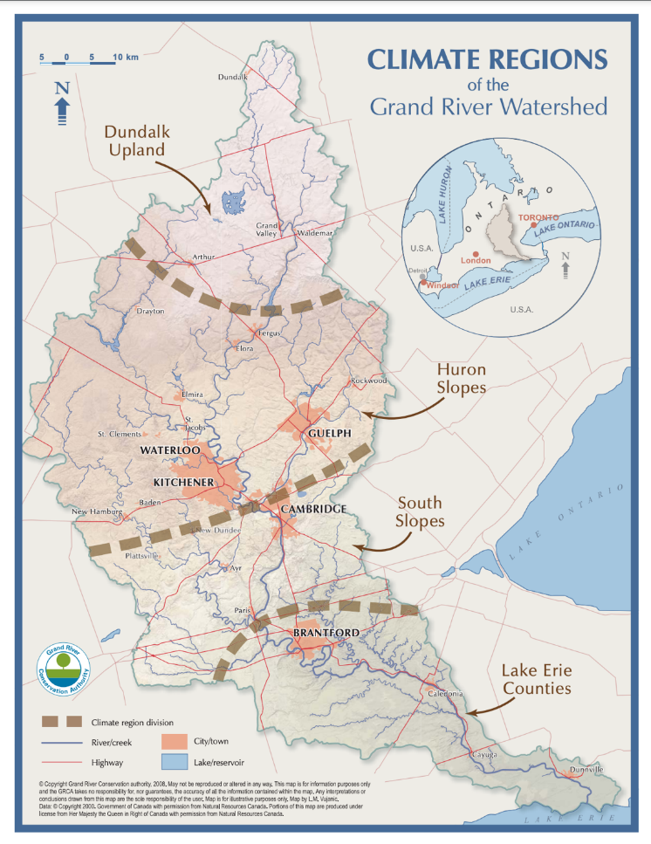

**Figure 6.1.1.** Climate regions of the Grand River Watershed, showing Mill Creek just south of the boundary between the Huron Slopes and South Slopes regions (GRCA, n.d.d).

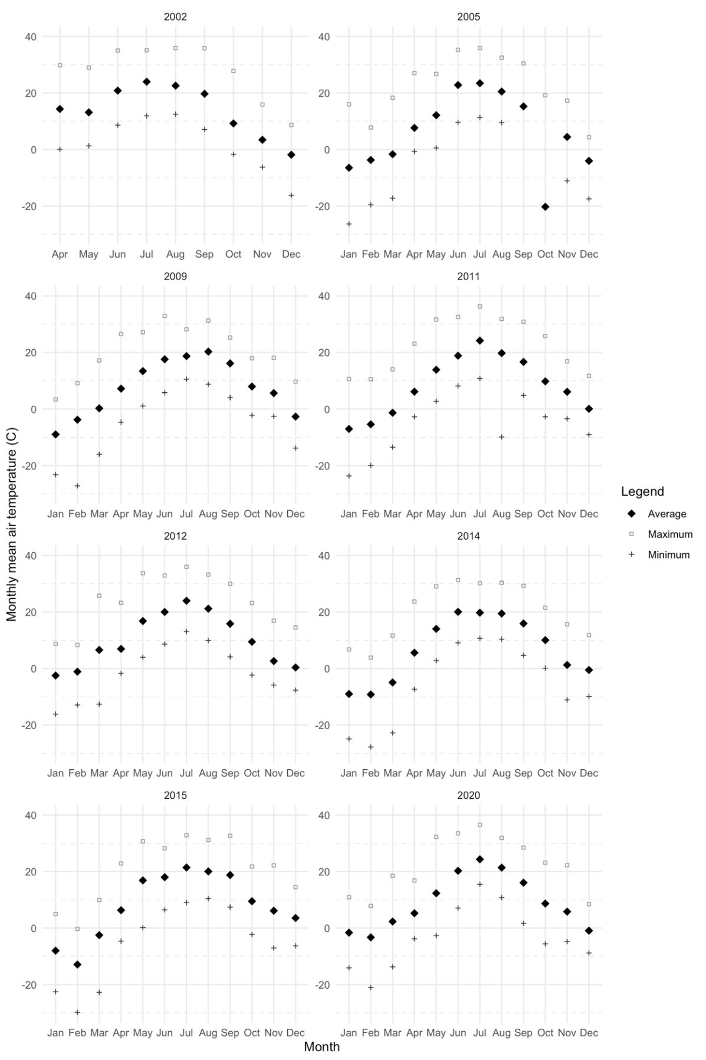

**Figure 6.2.1.1.** Average monthly air temperature in the years containing the most extreme hot and cold air temperatures at the Shade’s Mills Dam Climate Station.

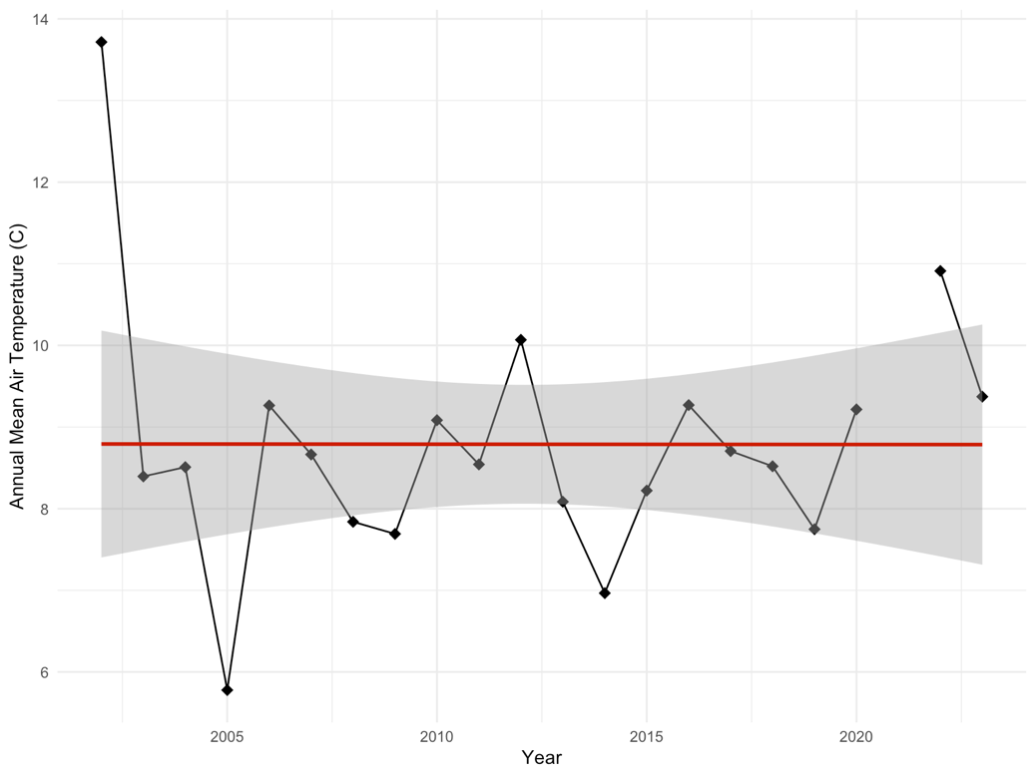

**Figure 6.2.2.1.** Annual mean air temperature (°C) at the Cambridge Shade’s Mills Dam Climate Station from 2003-2023 (n = 183979 observations, 21 years). Data from 2021 captures < 8 months and was excluded from this analysis.

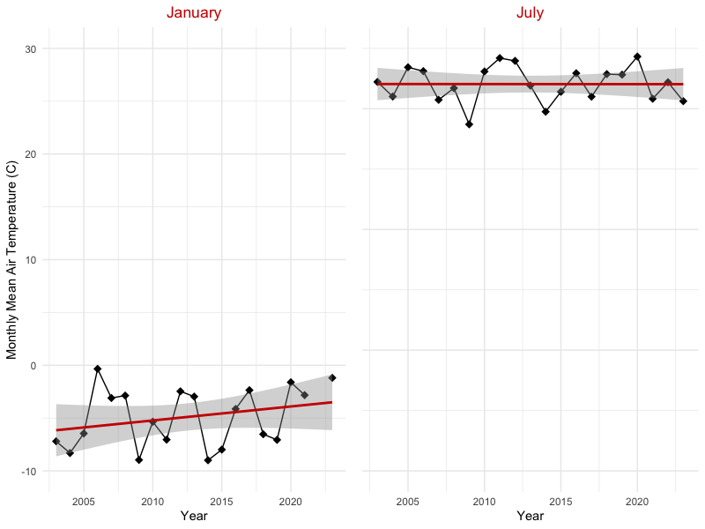

**Figure 6.2.2.2.** January mean air temperature (°C) at the Cambridge Shade’s Mills Dam Climate Station from 2003-2023 (n = 14854 observations, 20 years), and July mean air temperature (°C) 2003-2023 (n = 15337 observations, 21 years). Data from 2022 was missing for January.

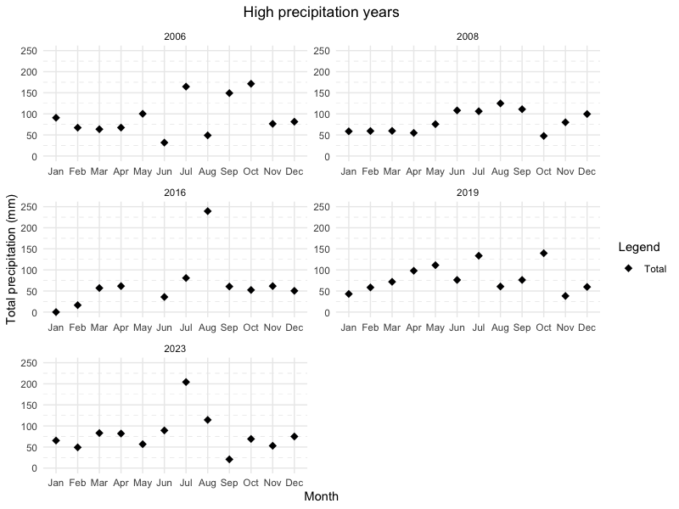

**Figure 6.3.1.1.** Total monthly precipitation in the years with the highest total precipitation at the Shade‘s Mills Dam Climate Station.

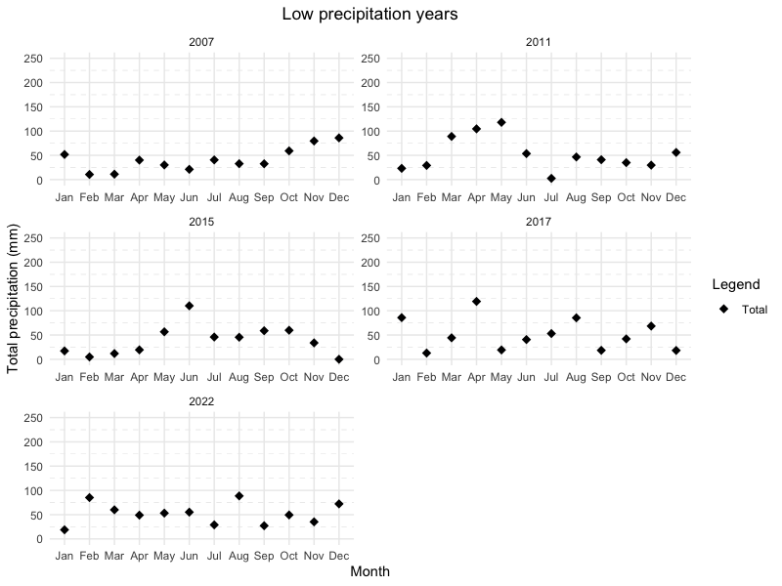

**Figure 6.3.1.2.** Total monthly precipitation in the years with the lowest total precipitation at the Shade‘s Mills Dam Climate Station.

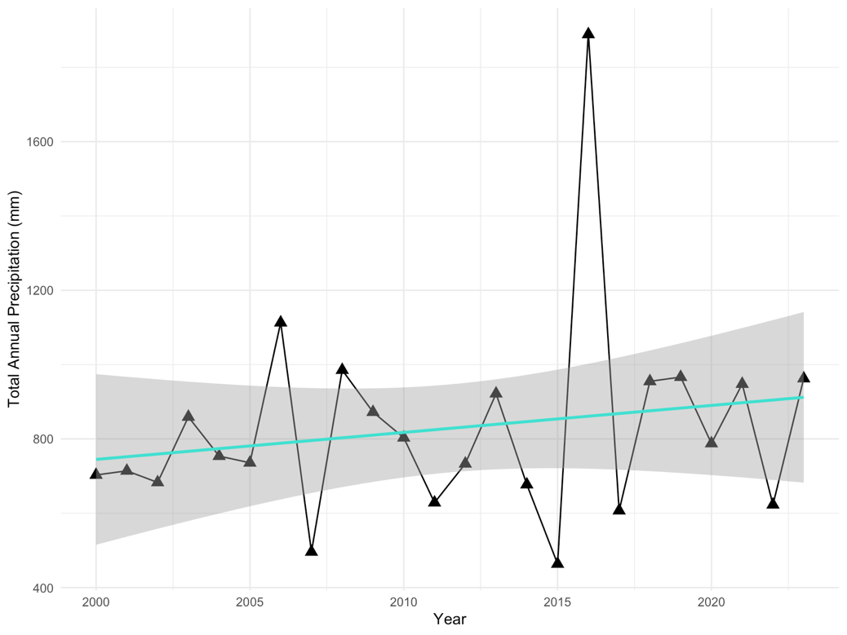

**Figure 6.3.1.** Total annual precipitation (mm) at the Cambridge GRCA Head Office Climate Station from 2000-2023 (n = 210093 observations, 23 years).

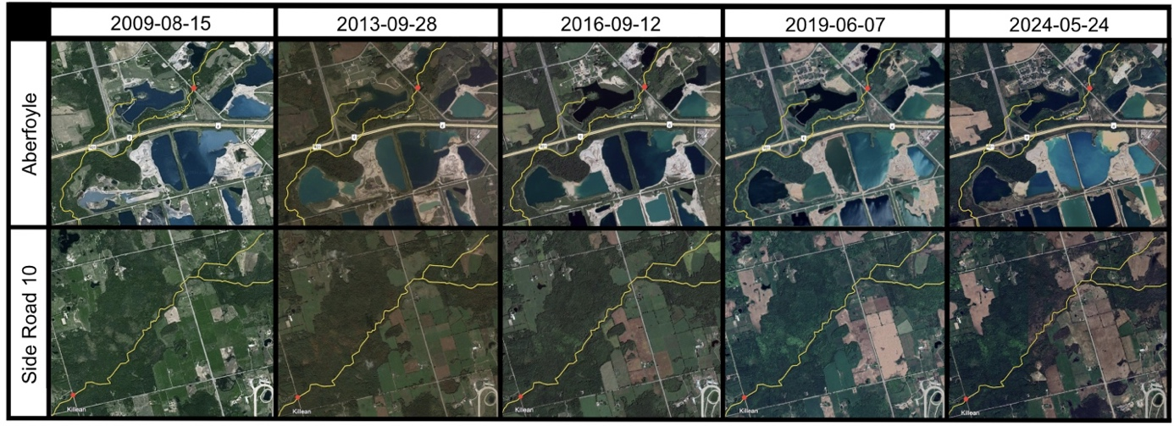

**Figure 7.6.1.** Changes in land use surrounding the Mill Creek Subwatershed in Puslinch from 2009-2024. Images were extracted from Google Earth. Red dots indicate continuous gauge stations at Side Road 10 and Aberfoyle, and the yellow line highlights Mill Creek.

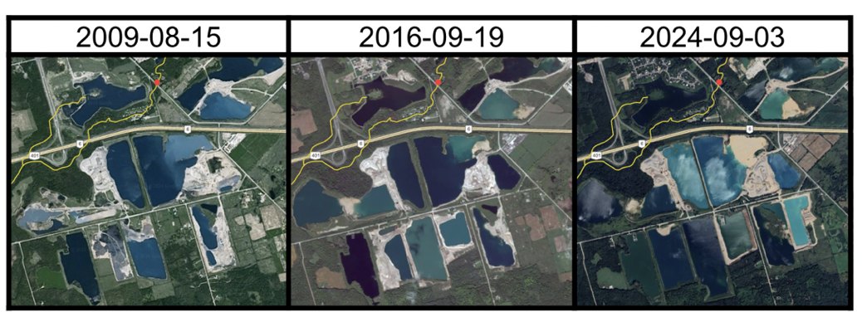

**Figure 7.6.2.** Changes in aggregate pits near the Aberfoyle stretch of the Mill Creek Subwatershed from 2009 to 2024. Images were extracted from Google Earth. The red dot indicates the continuous gauge station in Aberfoyle, and the yellow line highlights Mill Creek.

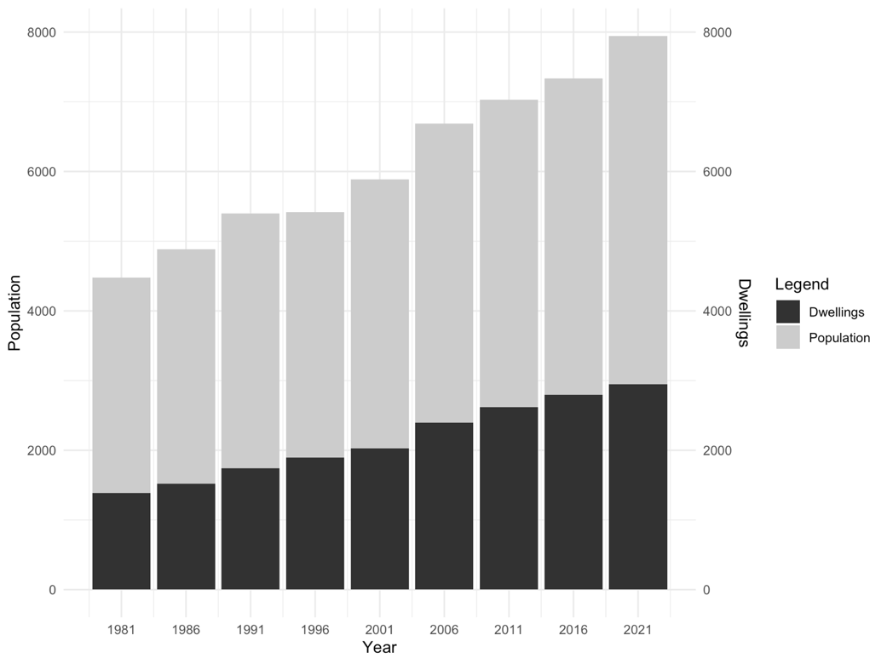

**Figure 7.6.3.** Changes in total population and number of private dwellings in the Township of Puslinch, Ontario from 1981-2021 (Statistics Canada 1981, 1986, 1991, 1996, 2001, 2006, 2011, 2016, 2021).

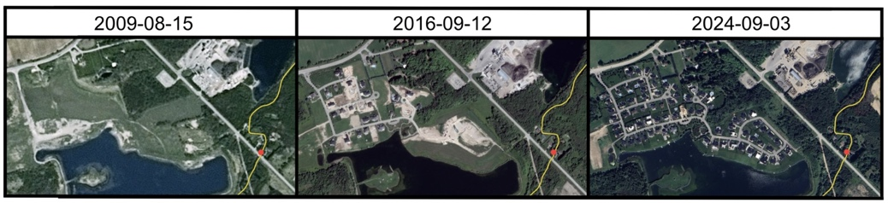

**Figure 7.6.4.** Changes in land use and housing near the Aberfoyle reach of Mill Creek from 2009-2024. Images were extracted from Google Earth. The red dot indicates the continuous gauge station in Aberfoyle, and the yellow line highlights Mill Creek.

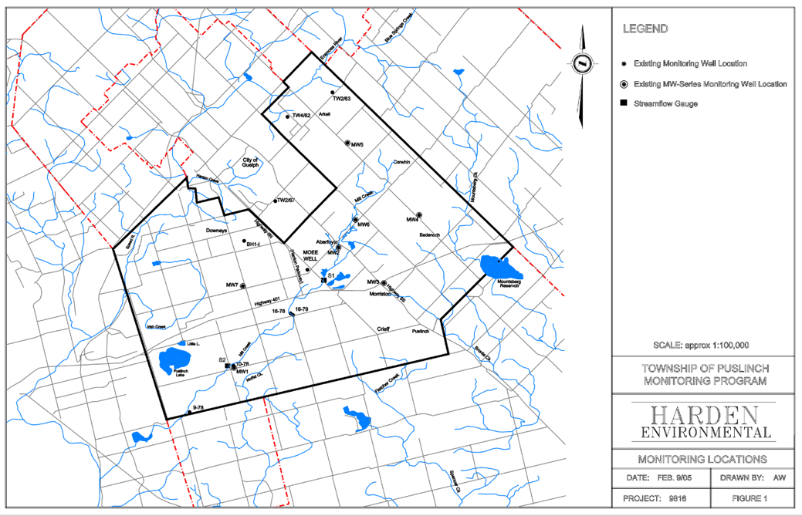

**Figure 8.1.** Locations of groundwater wells on Mill Creek monitored by Harden Environmental (2005).

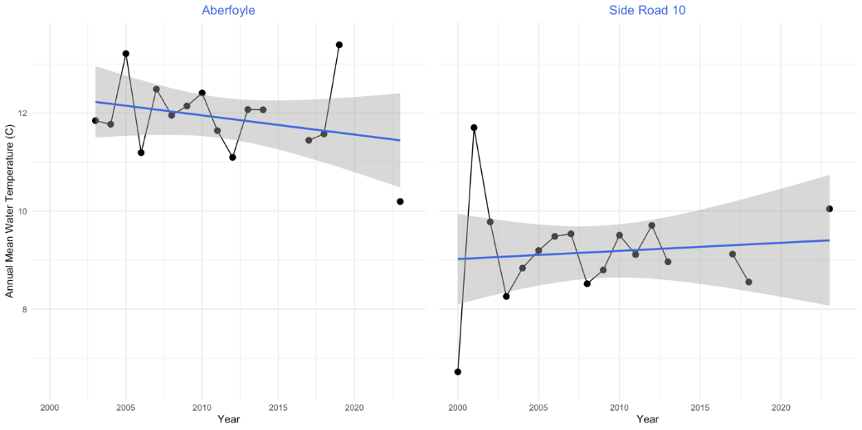

**Figure 9.1.1.** Annual mean water temperature (C) at the Aberfoyle (left) and Side Road 10 (right) gauge stations. Data for Aberfoyle is available from 2003-2023, excluding 2015, 2016, and 2022 which capture < 8 months (n = 114646 observations, 16 years). Data for Side Road 10 is available from 2000-2023, excluding 2014, 2016, 2019, and 2022 which capture < 8 months (n = 157725 observations, 17 years).

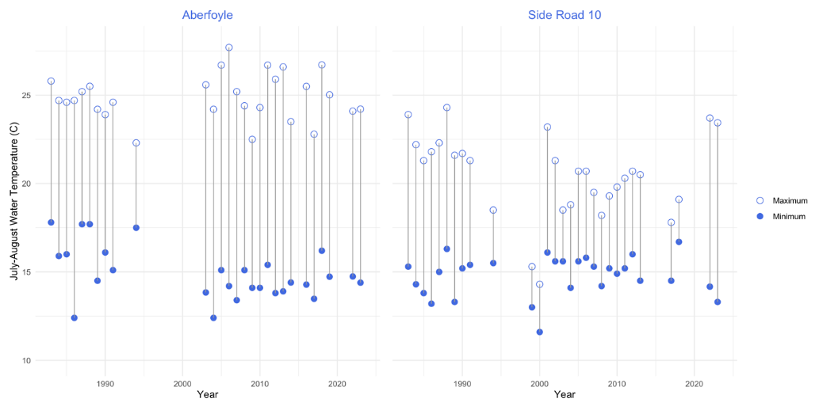

**Figure 9.1.2.** Maximum and minimum water temperature (C) during July and August from 1983-2023 at the Aberfoyle (left) and Side Road 10 (right) gauge stations. Data from 1983-1991 was sourced from documents archived in the GRCA Head Office (GRCA, 1991), 1994 from the 1196 Subwatershed Report (GRCA, 1996, pp. 3-98 & 3-99), and 2003-2023 from the GRCA continuous data downloads (n = 29 years).

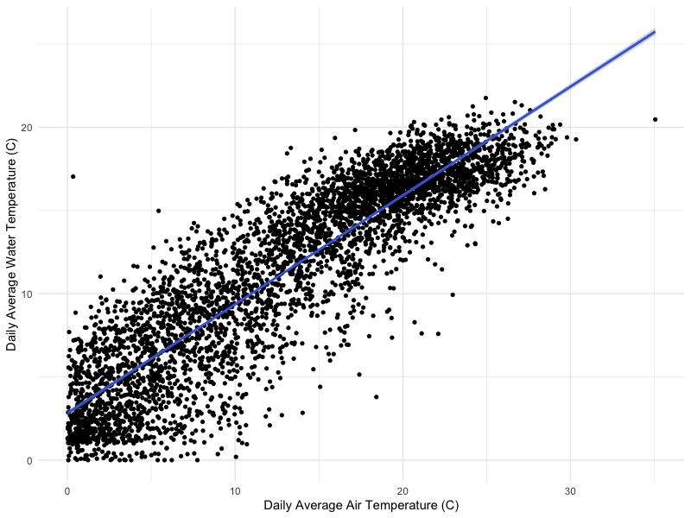

**Figure 9.1.3.** Daily average water temperature (C) at the Side Road 10 gauge station as a function of daily average air temperature (C) at the Cambridge Shade’s Mills Climate Station, from 2002-2023 (n=22 years, 4443 days).

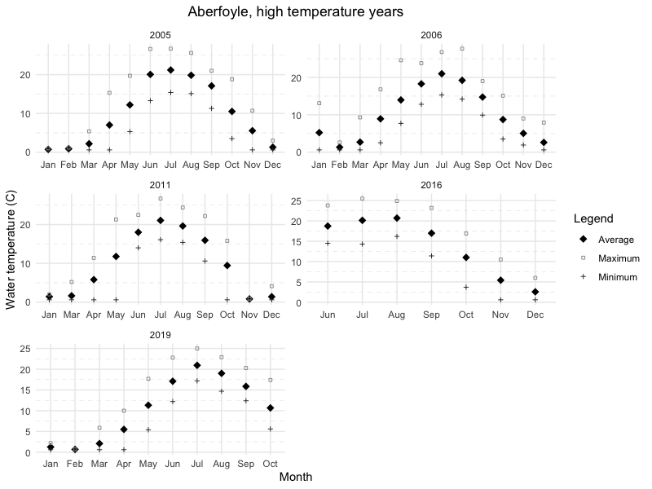

**Figure 9.1.4.** Average monthly water temperature in the years containing the most extreme high water temperatures at the Aberfoyle continuous gauge station.

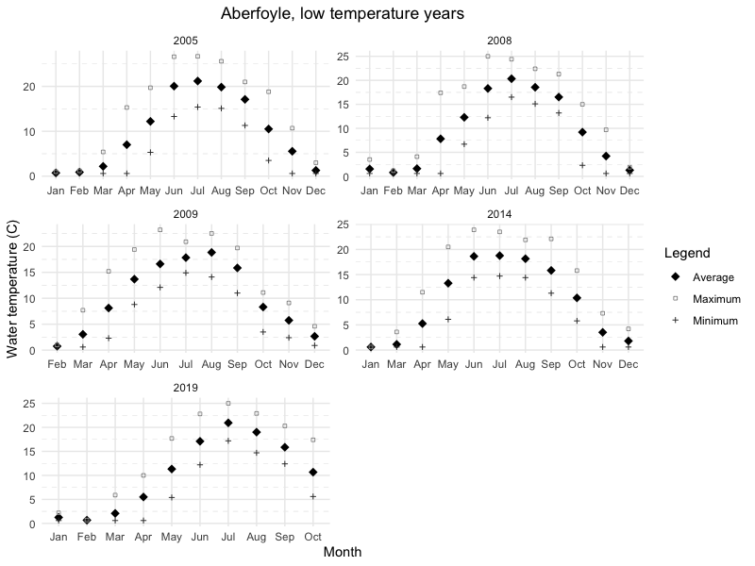

**Figure 9.1.5.** Average monthly water temperature in the years containing the most extreme low water temperatures at the Aberfoyle continuous gauge station.

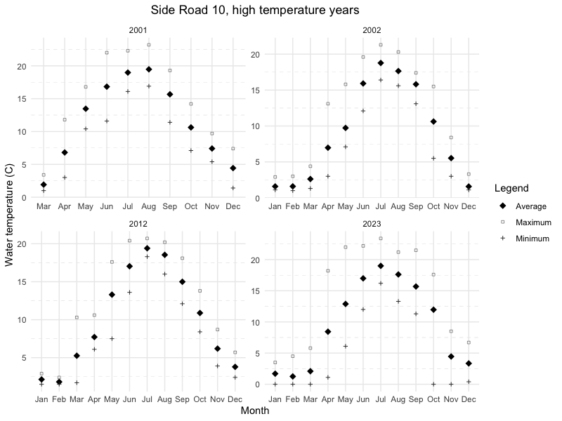

**Figure 9.1.6.** Average monthly water temperature in the years containing the most extreme high water temperatures at the Side Road 10 continuous gauge station.

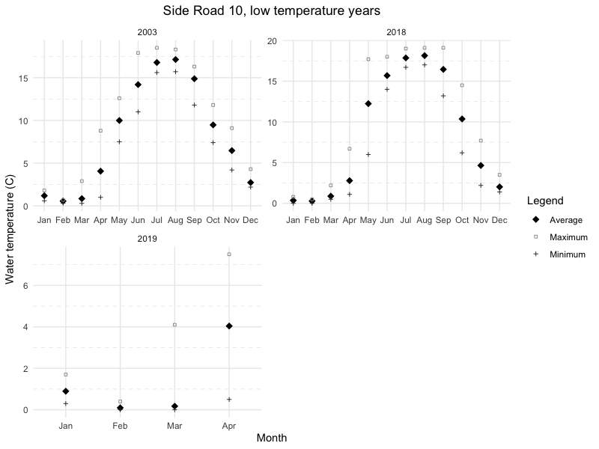

**Figure 9.1.7.** Average monthly water temperature in the years containing the most extreme low water temperatures at the Side Road 10 continuous gauge station.

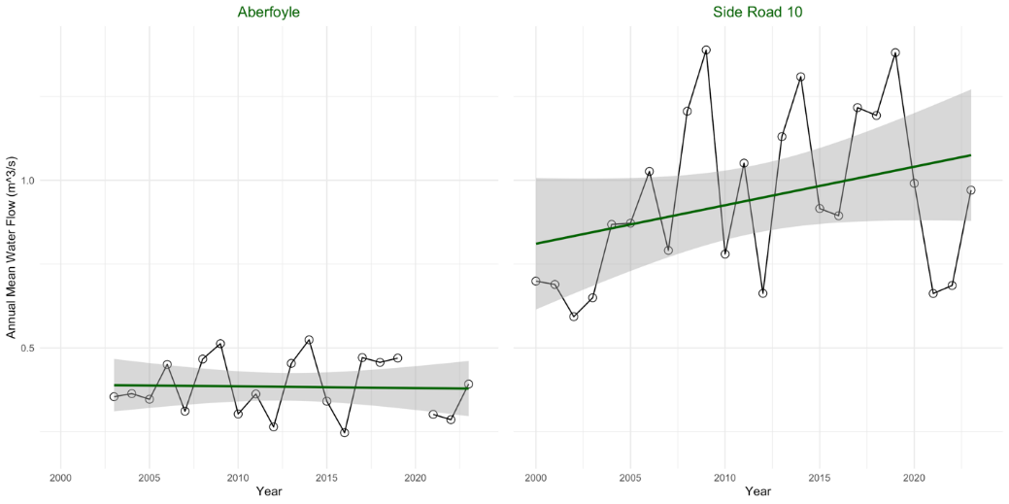

**Figure 9.2.1.** Annual mean water flow (m3/s) at the Aberfoyle (left) and Side Road 10 (right) gauge stations. Data for Aberfoyle is available from 2003-2023, excluding 2020 which captures < 8 months (n = 169418 observations, 20 years). Data for Side Road 10 is available from 2000-2023 (n = 210721 observations, 24 years).

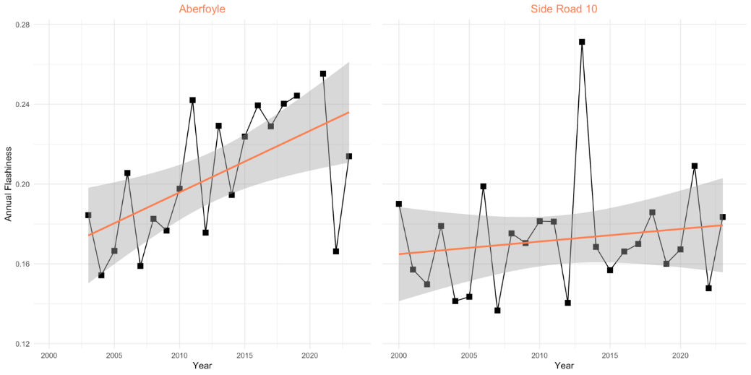

**Figure 9.2.2.** Annual flashiness index values at the Aberfoyle (left) and Side Road 10 (right) gauge stations. Flow data to calculate flashiness for Aberfoyle is available from 2003-2023, excluding 2020 which captures < 8 months (n = 20 years). Data for Side Road 10 is available from 2000-2023 (n = 24 years).

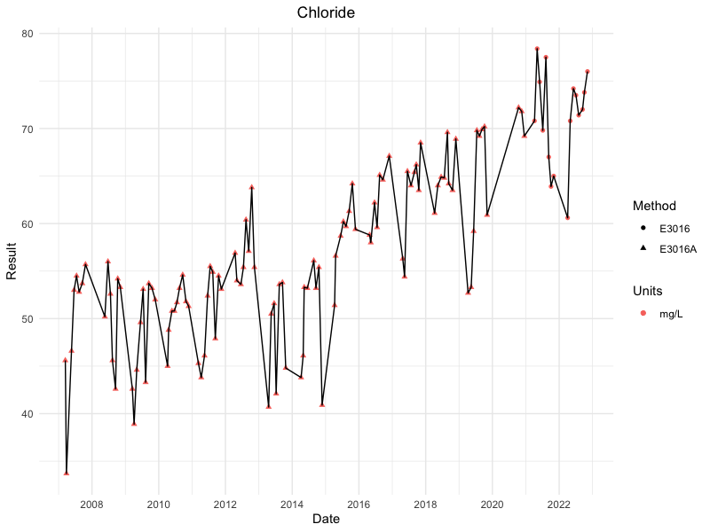  
**Figure 9.3.1.1.** Chloride concentration (mg/L) from grab samples at the Side Road 10 bridge crossing for the PWQMN program from 2007-2022 (n = 123 samples, 15 years).

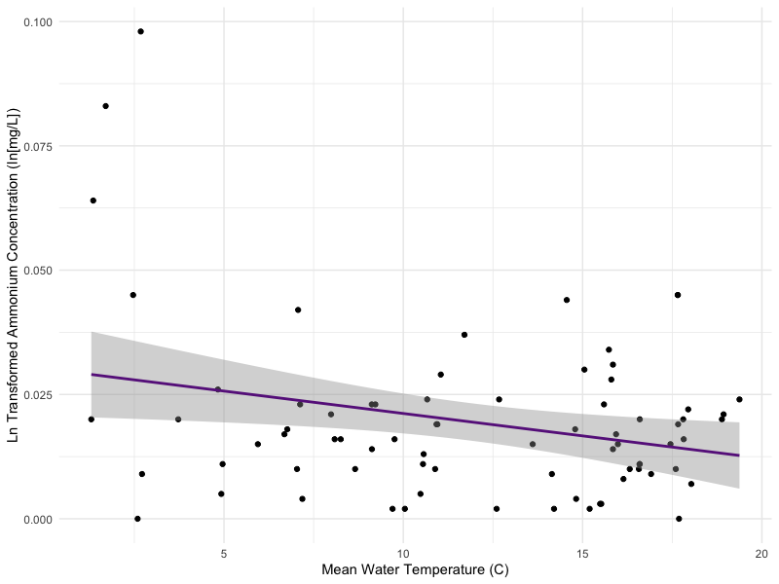

**Figure 9.3.1.2.** Effect of mean water temperature (C) over the 36 hours prior to a grab sample on ln transformed chloride concentration (mg/L) from grab samples at the Side Road 10 bridge crossing for the PWQMN program from 2077-2022 (n = 123 samples, 15 years).

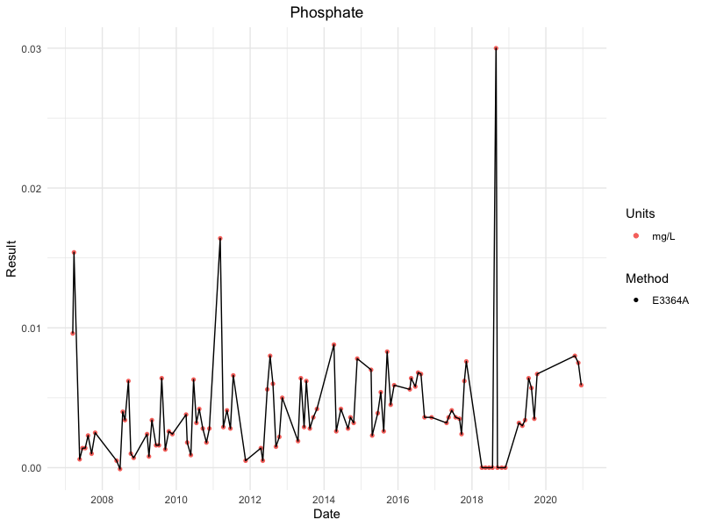  
**Figure 9.3.2.1.** Phosphate concentration (mg/L) from grab samples at the Side Road 10 bridge crossing for the PWQMN program from 2007-2020 (n = 102 samples, 13 years).

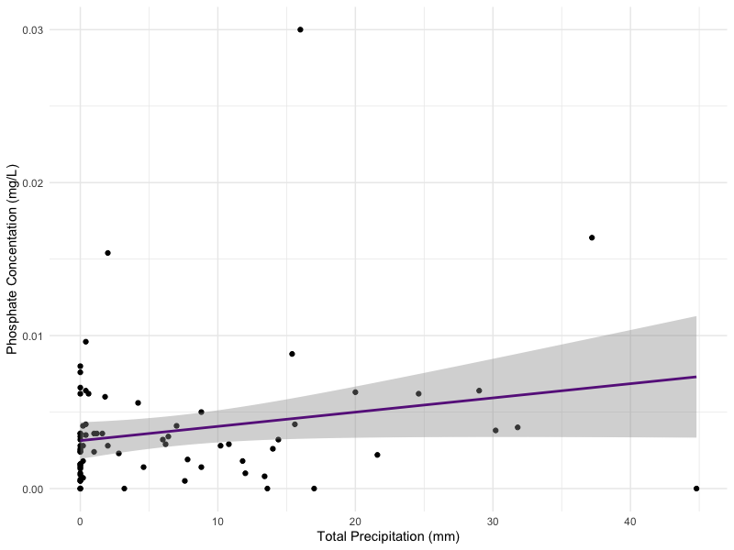

**Figure 9.3.2.2.** Effect of total precipitation (mm) over the 36 hours prior to a grab sample on phosphate concentration (mg/L) from grab samples at the Side Road 10 bridge crossing for the PWQMN program from 2007-2020 (n = 102 samples, 13 years).

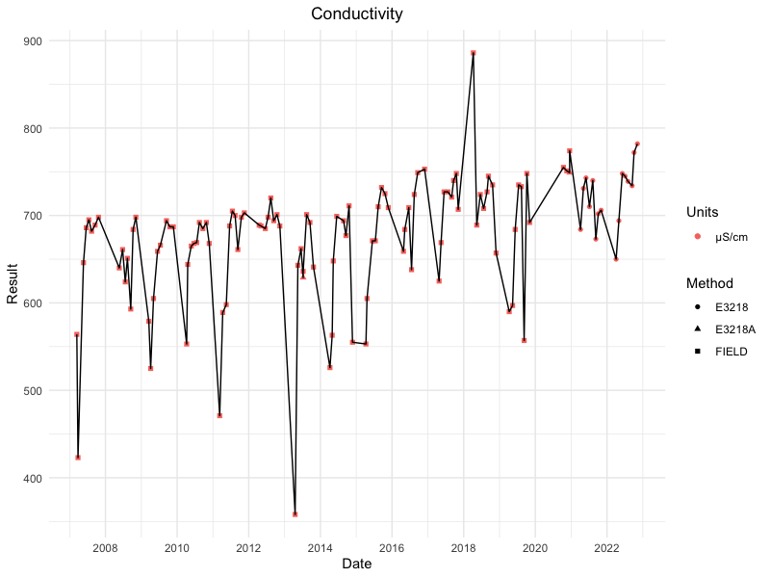  
**Figure 9.3.3.1.** Conductivity (uS/cm) from grab samples at the Side Road 10 bridge crossing for the PWQMN program from 2007-2022 (n = 124 samples, 15 years).

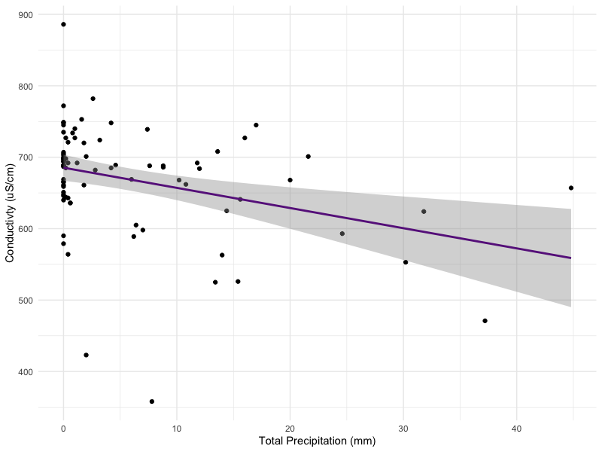

**Figure 9.3.3.2.** Effect of total precipitation (mm) over the 36 hours prior to a grab sample on conductivity (uS/cm) from grab samples at the Side Road 10 bridge crossing for the PWQMN program from 2007-2022 (n = 124 samples, 15 years).

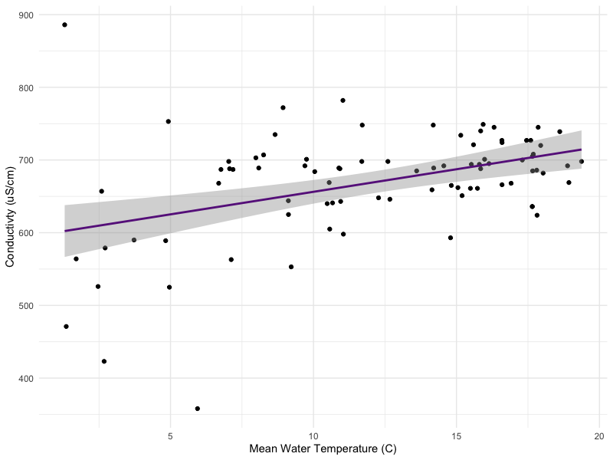

**Figure 9.3.3.3.** Effect of water temperature (C) over the 36 hours prior to a grab sample on conductivity (uS/cm) from grab samples at the Side Road 10 bridge crossing for the PWQMN program from 2007-2022 (n = 124 samples, 15 years).

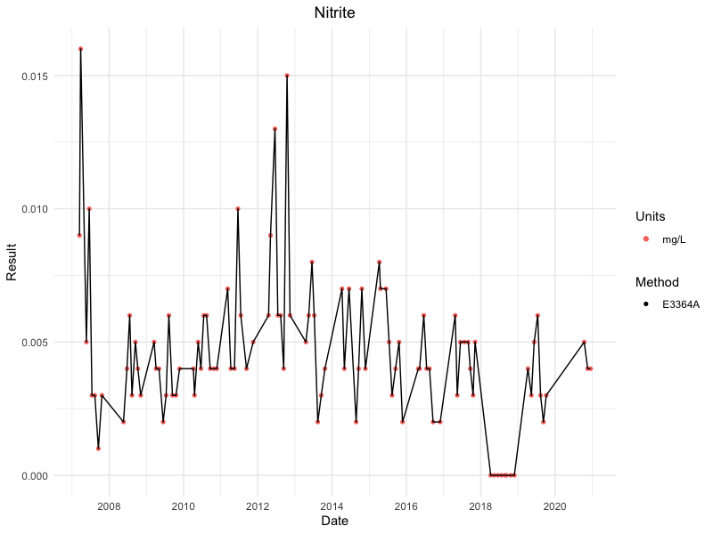  
**Figure 9.3.4.1.** Nitrite concentration (mg/L) from grab samples at the Side Road 10 bridge crossing for the PWQMN program from 2007-2022 (n = 104 samples, 13 years).

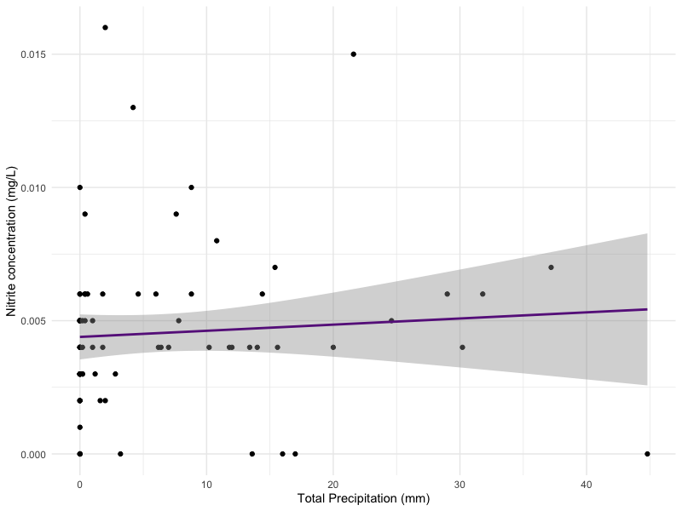

**Figure 9.3.4.2.** Effect of total precipitation (mm) over the 36 hours prior to a grab sample on nitrite concentration (mg/L) from grab samples at the Side Road 10 bridge crossing for the PWQMN program from 2007-2022 (n = 104 samples, 13 years).

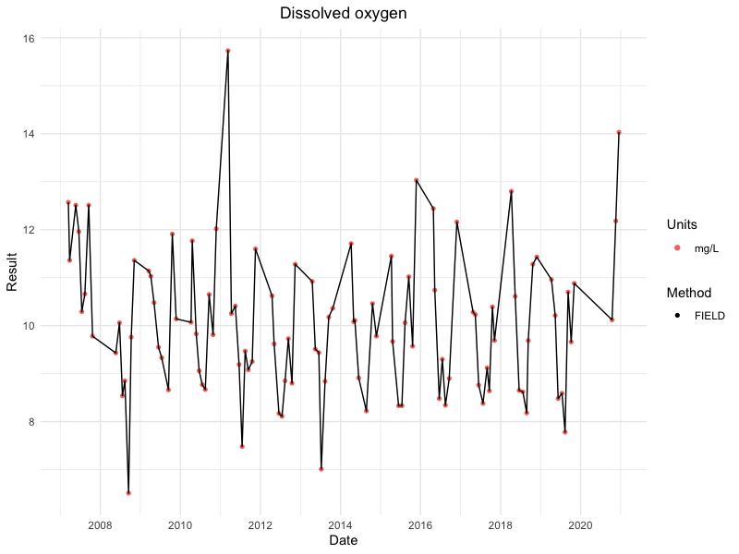  
**Figure 9.3.5.1.** Dissolved oxygen (mg/L) from grab samples at the Side Road 10 bridge crossing for the PWQMN program from 2007-2020 (n = 105 samples, 13 years).

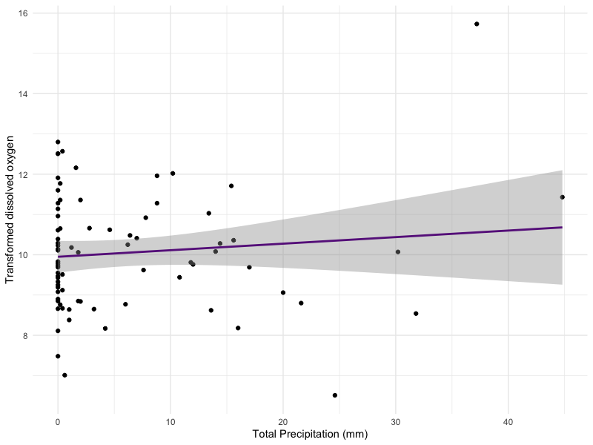

**Figure 9.3.5.1.** Effect of mean water temperature on log transformed dissolved oxygen (mg/L) from grab samples at the Side Road 10 bridge crossing for the PWQMN program from 2007-2020 (n = 105 samples, 13 years).

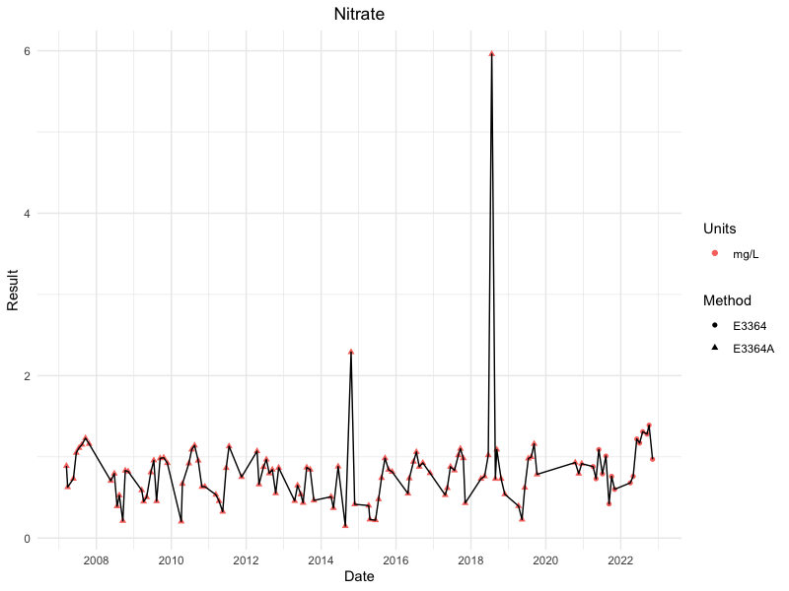  
**Figure 9.3.6.1.** Nitrate concentration (mg/L) from grab samples at the Side Road 10 bridge crossing for the PWQMN program from 2007-2022 (n = 116 samples, 15 years).

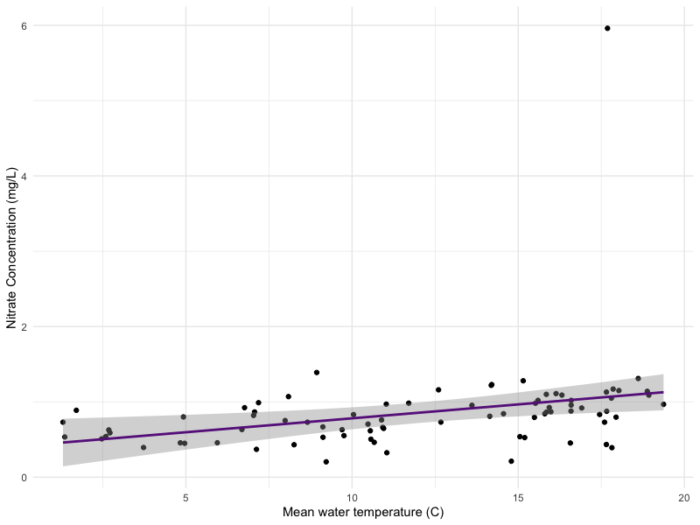

**Figure 9.3.6.2.** Effect of mean water temperature (C) over the 36 hours prior to a grab sample on nitrate concentration (mg/L) from grab samples at the Side Road 10 bridge crossing for the PWQMN program from 2007-2022 (n = 116 samples, 15 years).

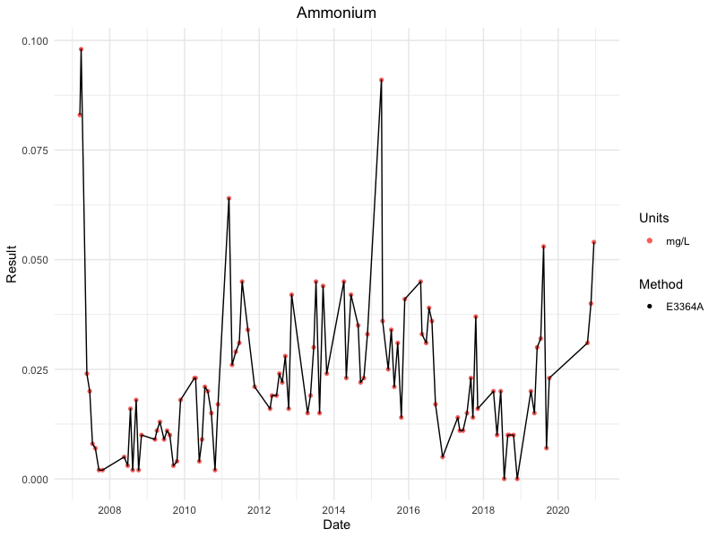  
**Figure 9.3.7.1.** Ammonium concentration (mg/L) from grab samples at the Side Road 10 bridge crossing for the PWQMN program from 2007-2019 (n = 76 samples, 12 years).

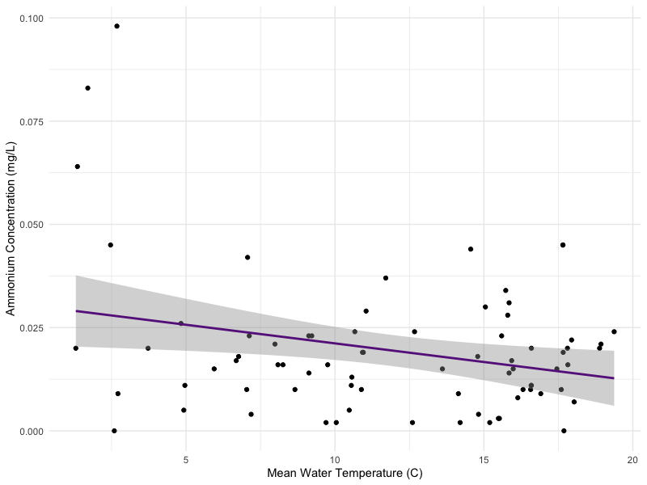

**Figure 9.3.7.2.** Effect of mean water temperature (C) over the 36 hours prior to a grab sample on ammonium concentration (mg/L) from grab samples at the Side Road 10 bridge crossing for the PWQMN program from 2007-2019 (n = 103 samples, 13 years).

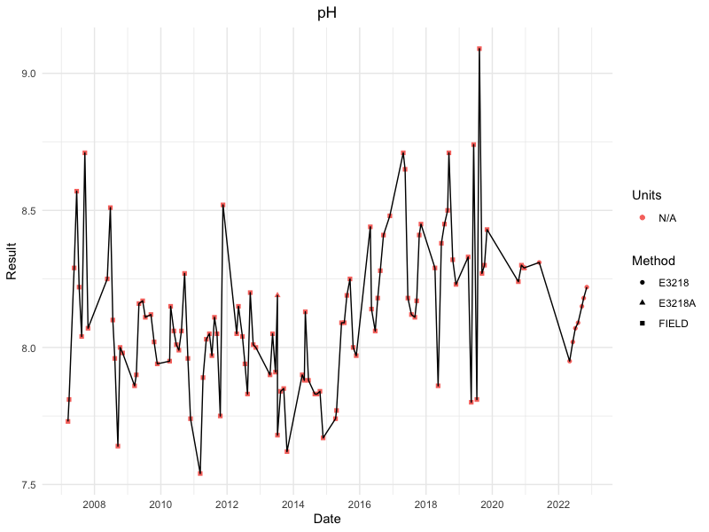  
  
**Figure 9.3.8.1.** pH values from grab samples at the Side Road 10 bridge collected for the PWQMN program from 2007-2022 (n = 116 samples, 15 years).

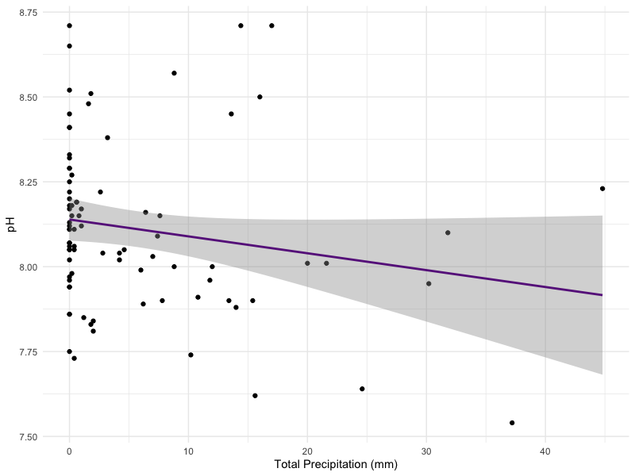

**Figure 9.3.8.2. T**he effect of total precipitation (mm) over the 36 hours prior to a grab sample on pH from grab samples at the Side Road 10 bridge collected for the PWQMN program from 2007-2022 (n = 116 samples, 15 years).

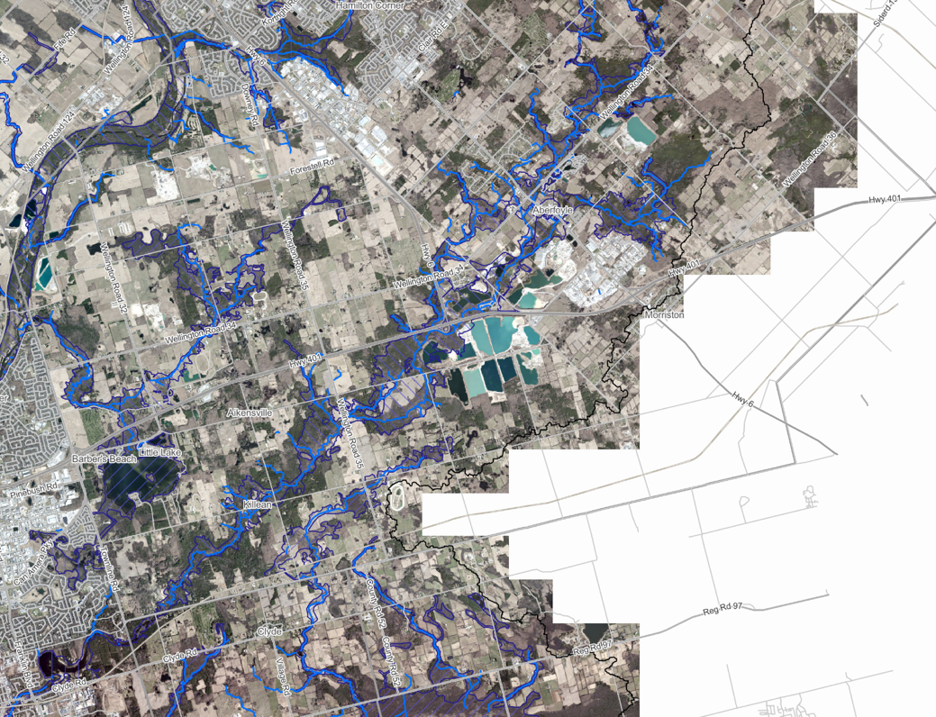

**Figure 9.4.1.** Floodplain zones around Mill Creek, mapped on the GRCA Web-GIS Application (GRCA, n.d.g). The purple striped zones are classified as floodplain. The black border marks the edge of the Grand River watershed, and white areas are outside this border. Regulated watercourses (including Mill Creek) are marked in blue.

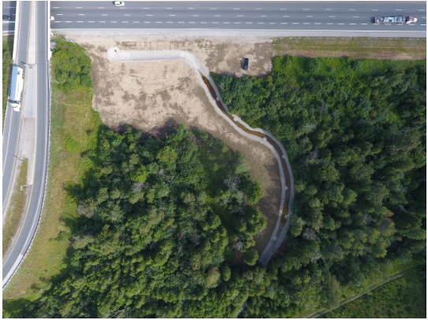

**Figure 10.2.1.** Aerial photograph of the point of loss area of the 2019 jet fuel spill into Mill Creek (Township of Puslinch, 2019).

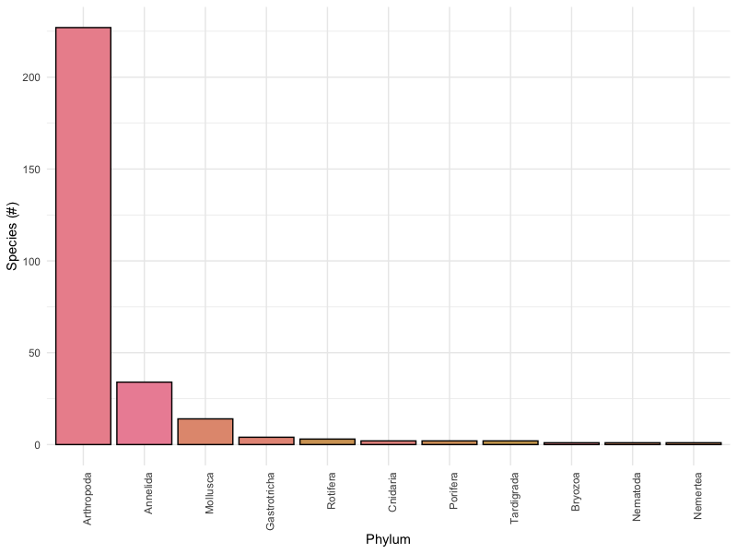  
**Figure 11.1.4.1.** Number of species detected by Phylum in the STREAM project, 2023.

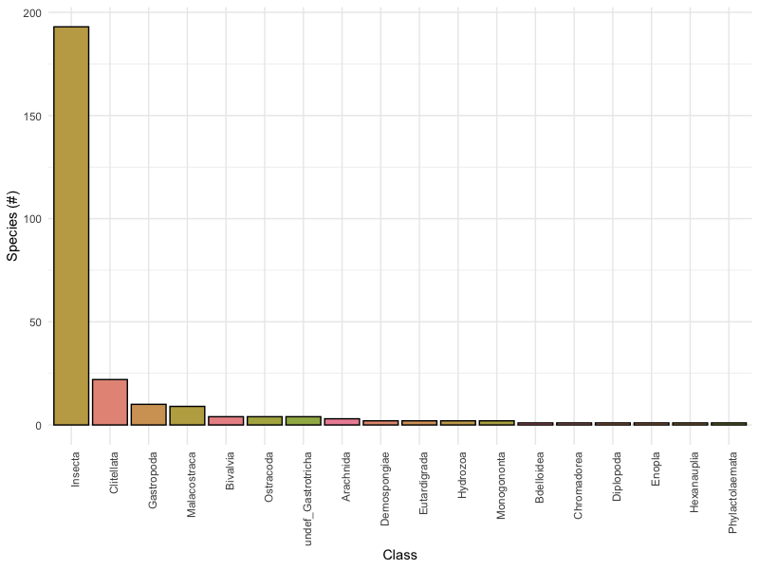

**Figure 11.1.4.2.** Number of species detected by Class in the STREAM project, 2023.

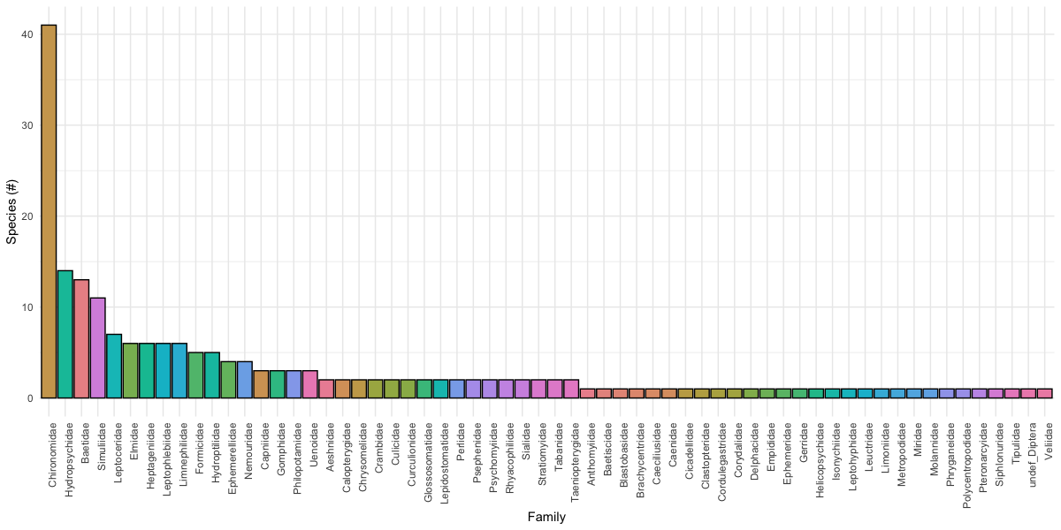**Figure 11.1.4.3.** Number of insect species detected by Family in the STREAM project, 2023.

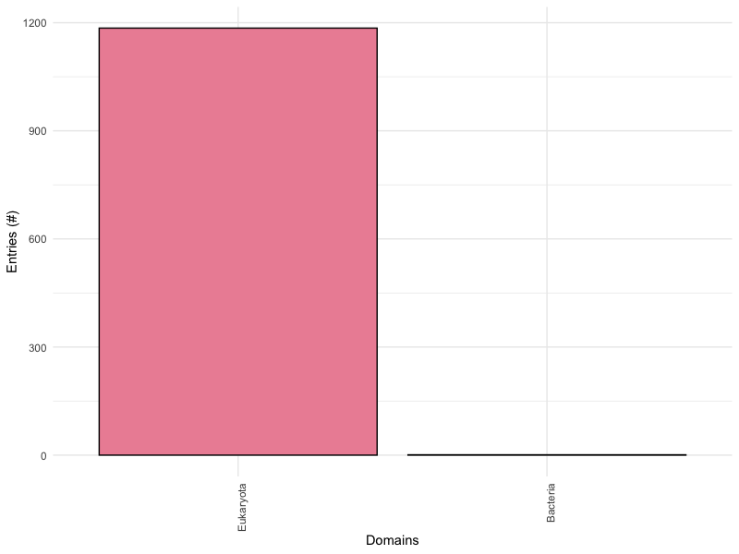

**Figure 11.2.1.** Proportion of entries in the ongoing biodiversity inventory, by Domain. Note that the relative abundance of each group reflects which groups are more frequently encountered, identified, and reported in public species records or surveyed for during conservation initiatives, not the actual abundance of that group in the subwatershed.

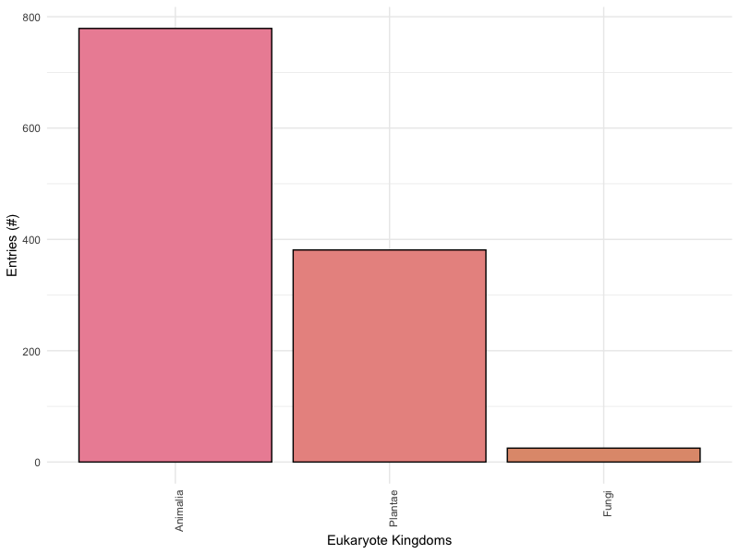

**Figure 11.2.2.** Proportion of entries in the ongoing biodiversity inventory, by Eukaryote Kingdom. Note that the relative abundance of each group reflects which groups are more frequently encountered, identified, and reported in public species records or surveyed for during conservation initiatives, not the actual abundance of that group in the subwatershed.

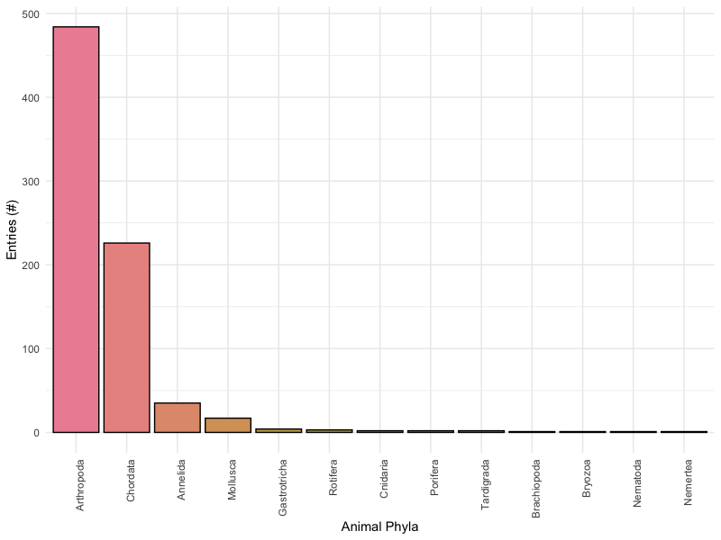

**Figure 11.2.3.** Proportion of entries in the ongoing biodiversity inventory, by Animal Phylum. Note that the relative abundance of each group reflects which groups are more frequently encountered, identified, and reported in public species records or surveyed for during conservation initiatives, not the actual abundance of that group in the subwatershed.

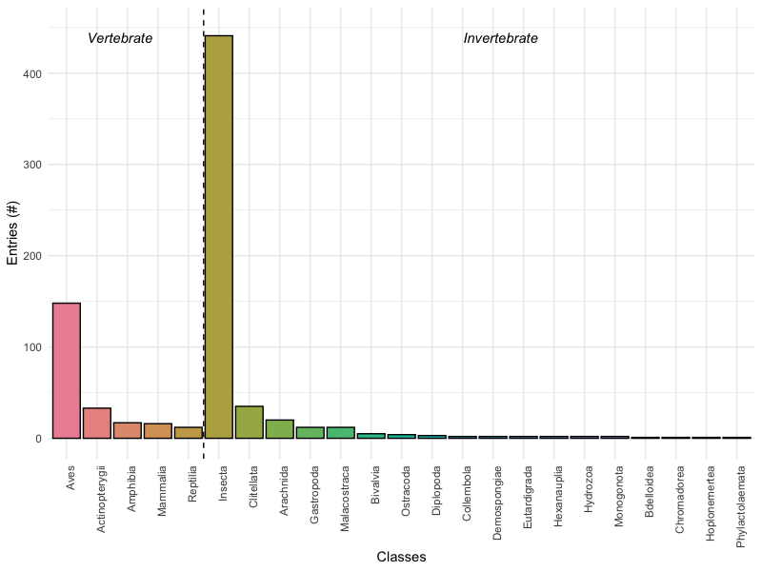

**Figure 11.2.4.** Proportion of entries in the ongoing biodiversity inventory, by Animal Class. The dashed vertical line separates vertebrate (Chordata) and invertebrate (outside Chordata) Classes. Note that the relative abundance of each group reflects which groups are more frequently encountered, identified, and reported in public species records or surveyed for during conservation initiatives, not the actual abundance of that group in the subwatershed.

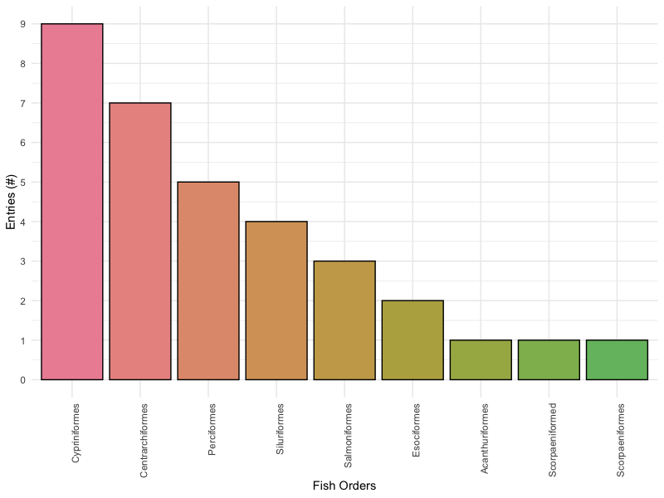

**Figure 11.2.5.** Proportion of fish entries in the ongoing biodiversity inventory by Order.

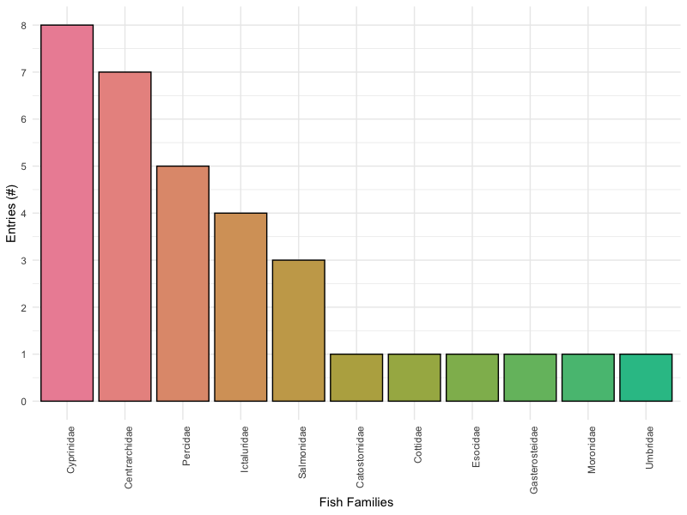

**Figure 11.2.6.** Proportion of fish entries in the ongoing biodiversity inventory by Family.

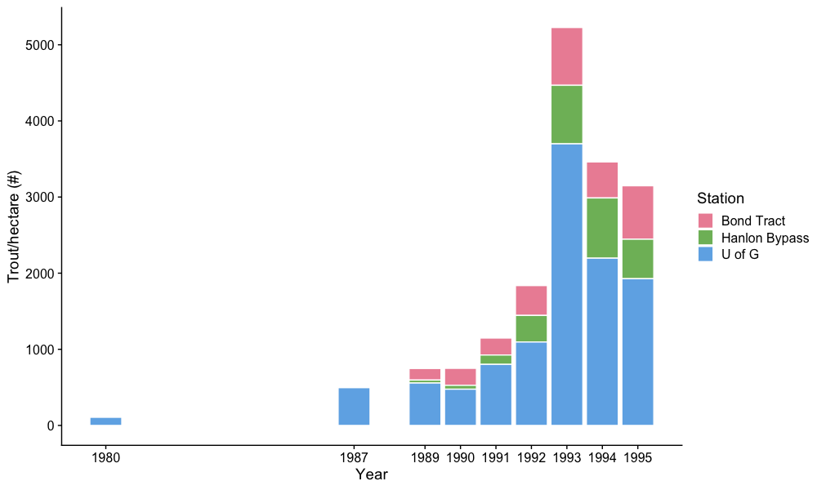

**Figure 11.3.1.1.** Brook and brown trout per hectare, from GRCA electrofishing at three stations on Mill Creek.

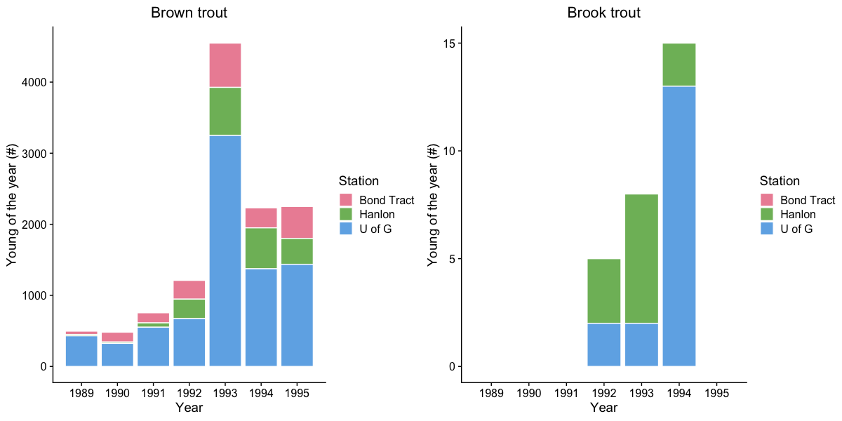**Figure 11.3.1.2.** Brook and brown trout young of the year (YOY) electrofishing catch from GRCA monitoring at three stations on Mill Creek.



**Figure 13.1.1.** SER social benefits wheel for the restoration project of Mill Creek. This wheel is graded using a five-star system for evaluating the progress towards social goals in a restoration project.



**Figure 14.2.1** Society for Ecological Restoration (SER) restoration wheel for Mill Creek.

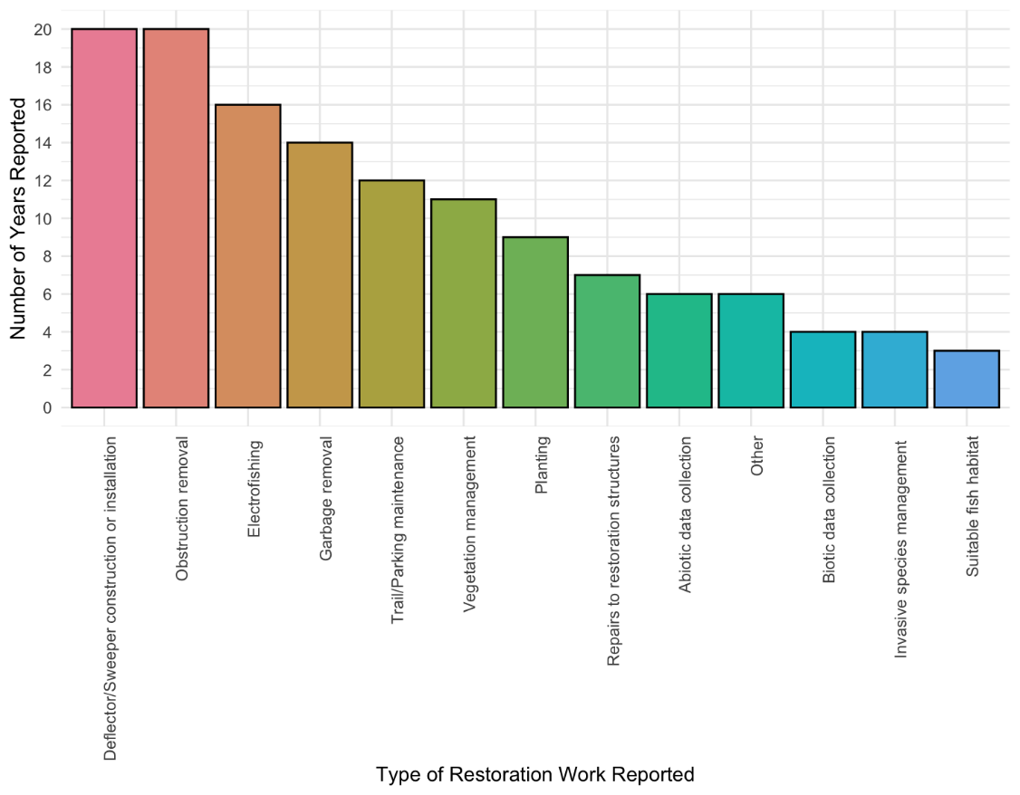

**Figure 14.4.1.** Type of restoration work completed by the Mill Creek Stewardship Rangers over the years, by frequency.

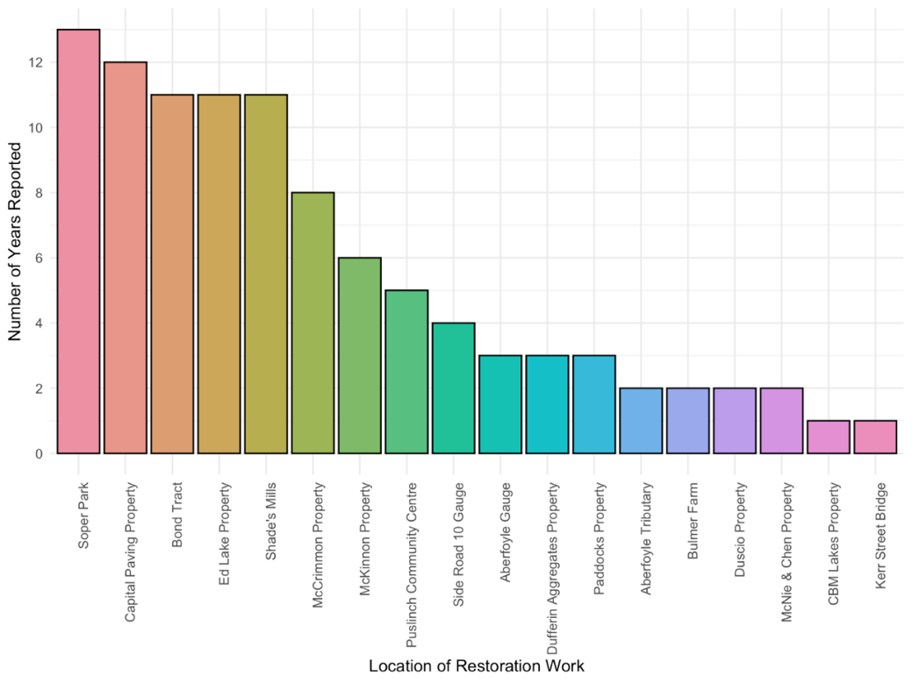

**Figure 14.4.2.** Location of Mill Creek Stewardship Ranger restoration work sites over the years, by frequency.

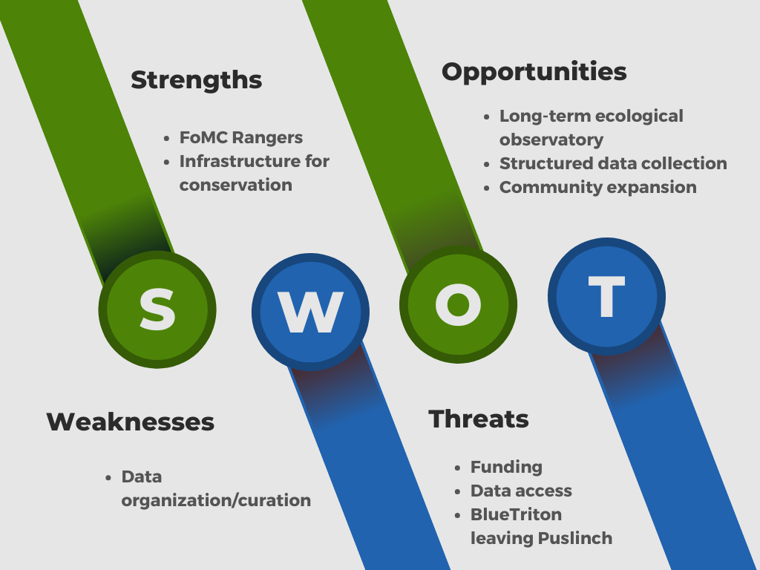

**Figure 15.1.1** SWOT analysis of the Friends of Mill Creek (FoMC) organization. This SWOT analysis identifies the Strengths, Weaknesses, Opportunities and Threats brought to the table by FoMC since they were first founded in 1997. FoMC is a volunteer and community-based group focused on rehabilitating the creek to a cold-water stream supporting brown and brook trout.

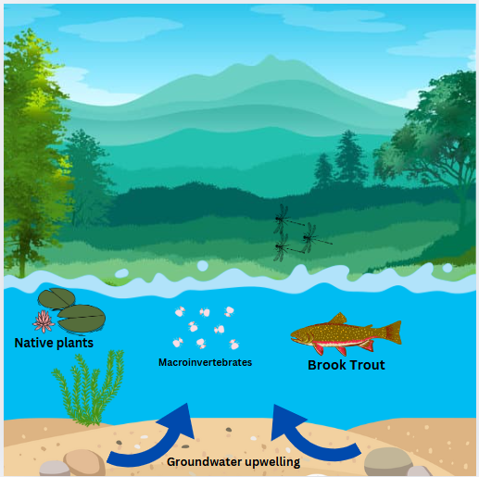

**Figure 15.2.1. Example question:** Before today, did you have knowledge of the other factors that contribute to the health of brook trout and aquatic ecosystem health?

Yes  No  Uncertain

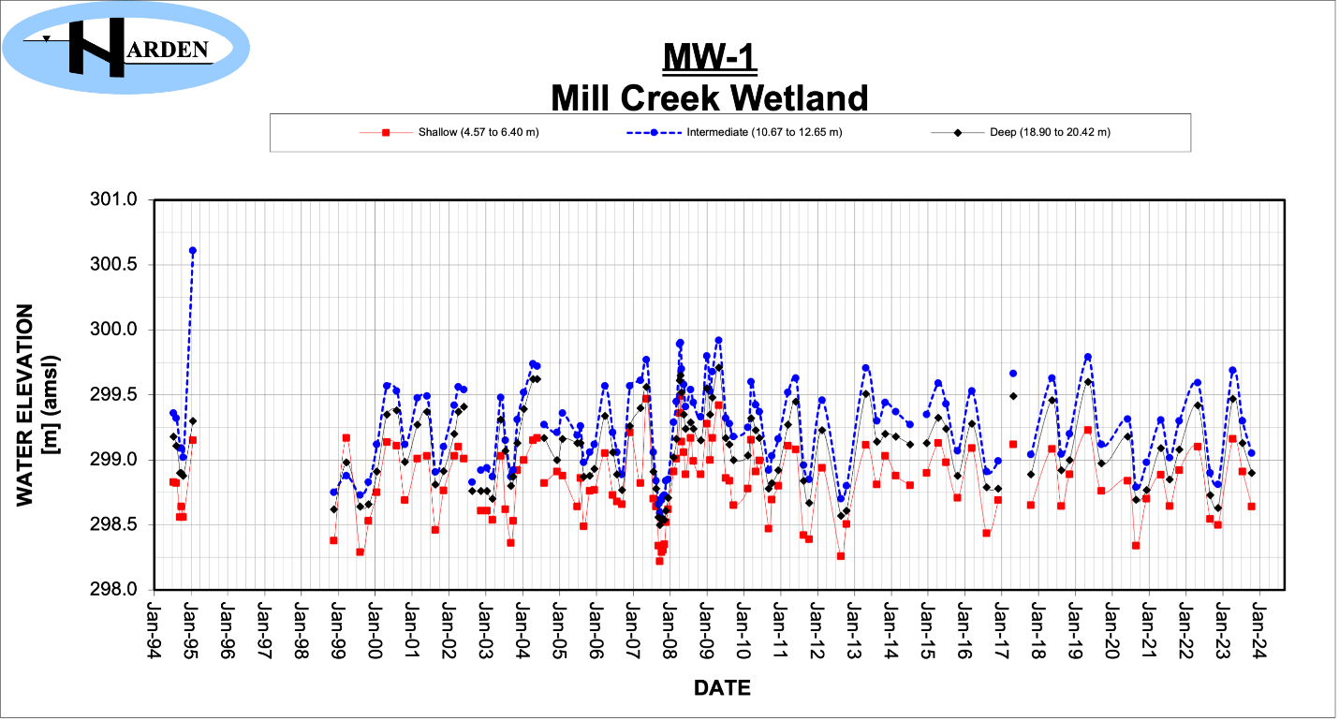**Figure A2.1.** January groundwater levels in the MW-1 Mill Creek Wetland well from 1994-2024 (Harden Environmental, n.d.a).

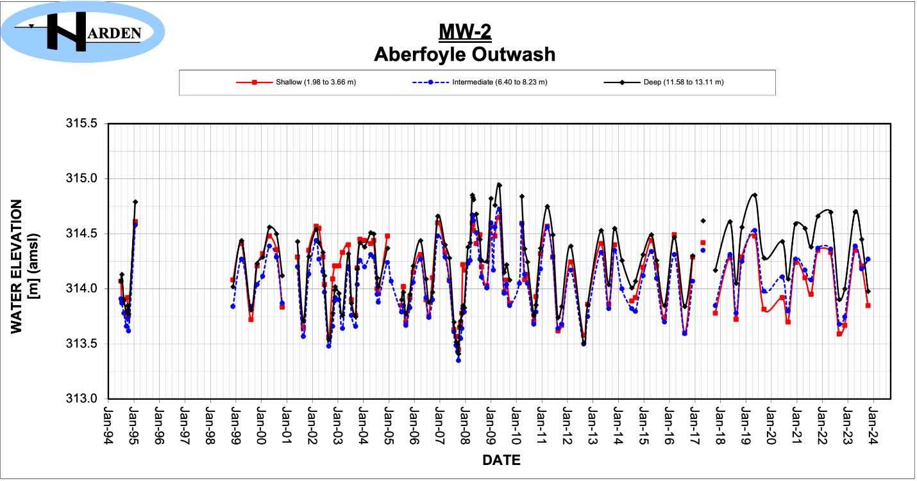**Figure A2.2.** January groundwater levels in the MW-2 Aberfoyle Outwash well from 1994-2024 (Harden Environmental, n.d.a).

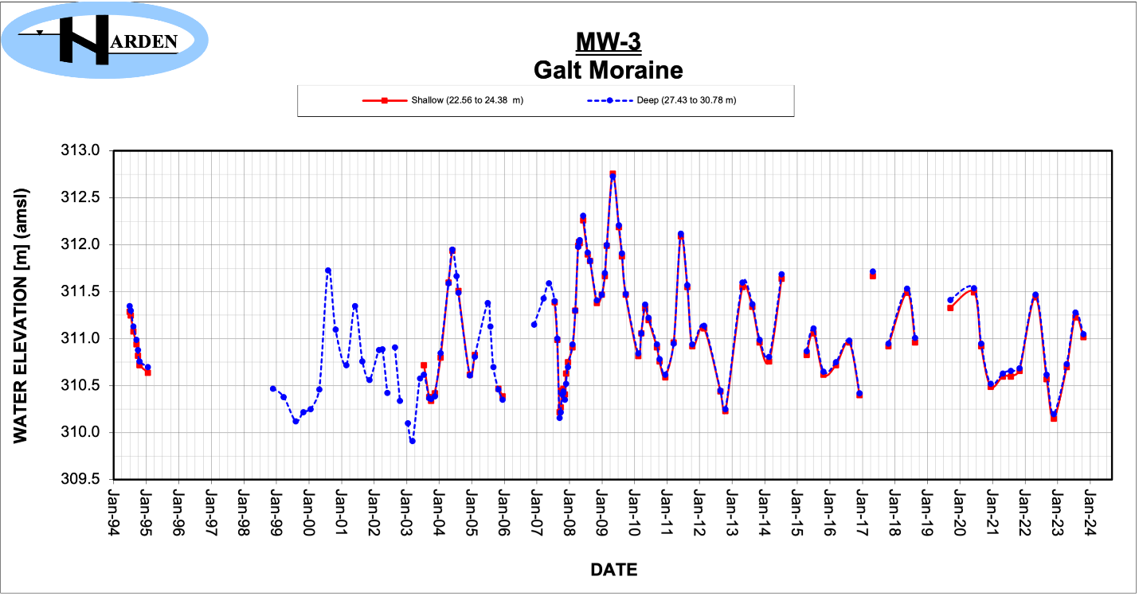**Figure A2.3.** January groundwater levels in the MW-3 Galt Moraine well from 1994-2024 (Harden Environmental, n.d.a).

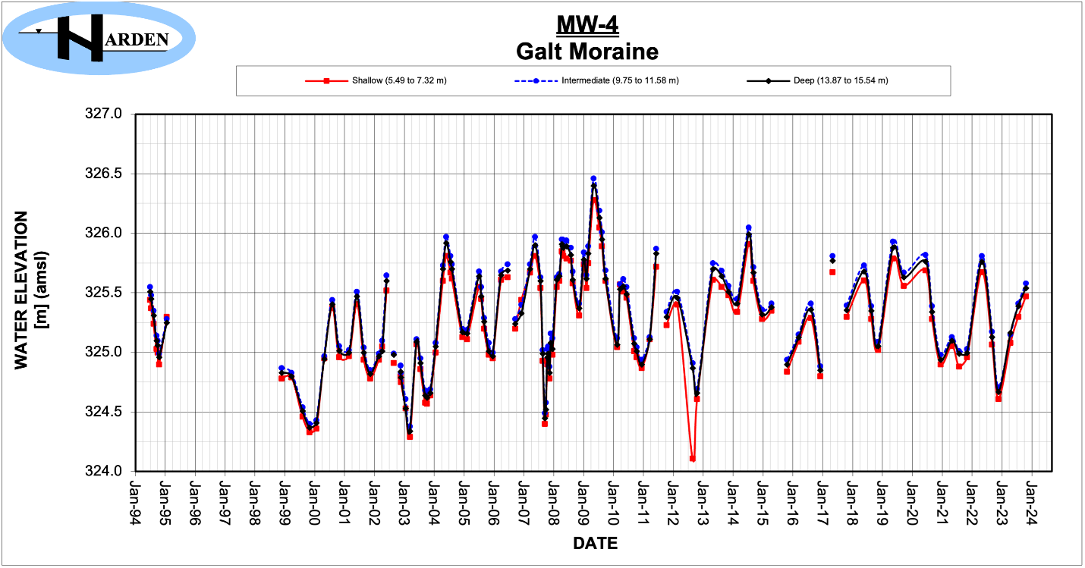**Figure A2.4**. January groundwater levels in the MW-4 Galt Moraine well from 1994-2024 (Harden Environmental, n.d.a).

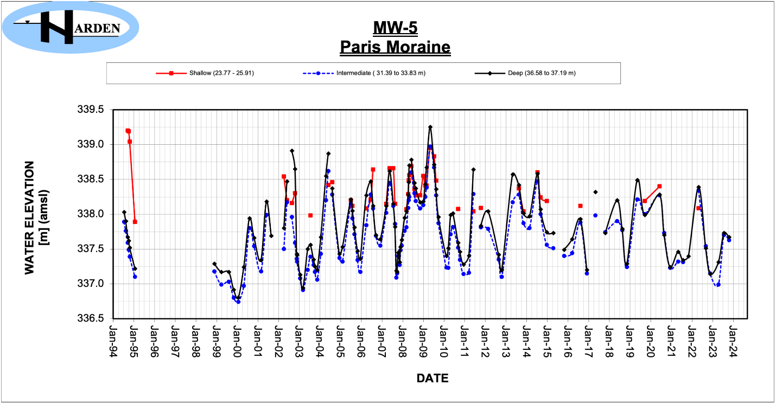**Figure A2.5.** January groundwater levels in the MW-5 Pairs Moraine well from 1994-2024 (Harden Environmental, n.d.a).

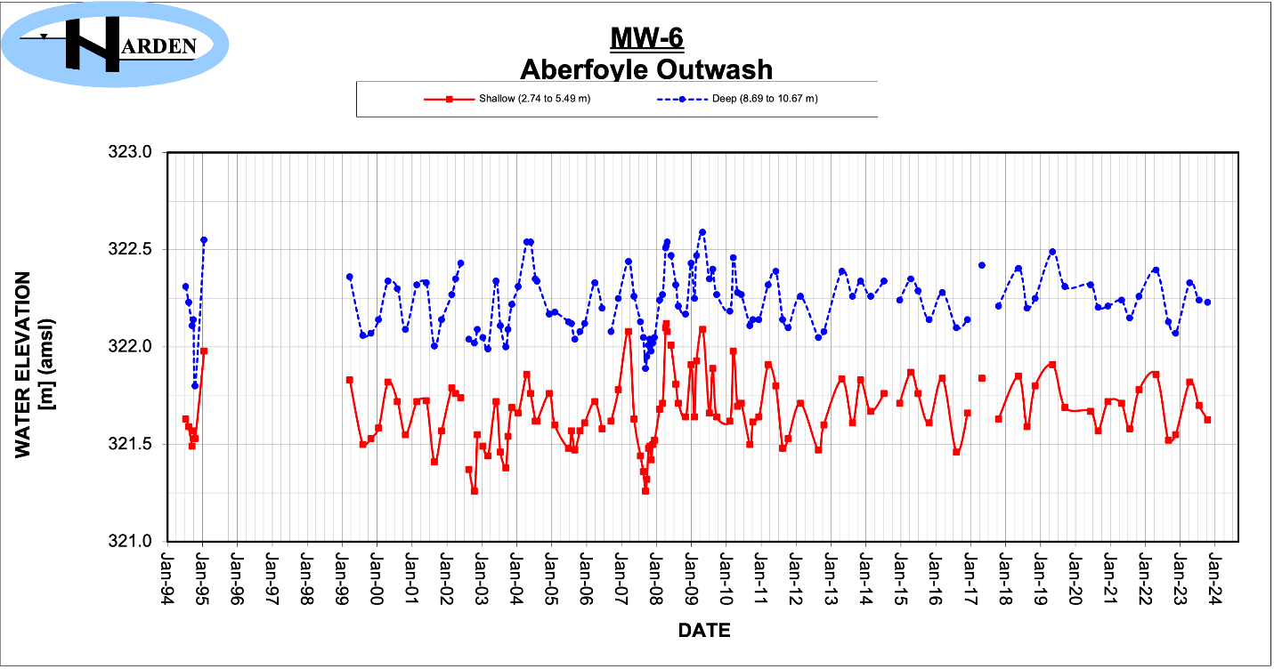**Figure A2.6.** January groundwater levels in the MW-6 Aberfoyle Outwash well from 1994-2024 (Harden Environmental, n.d.a).

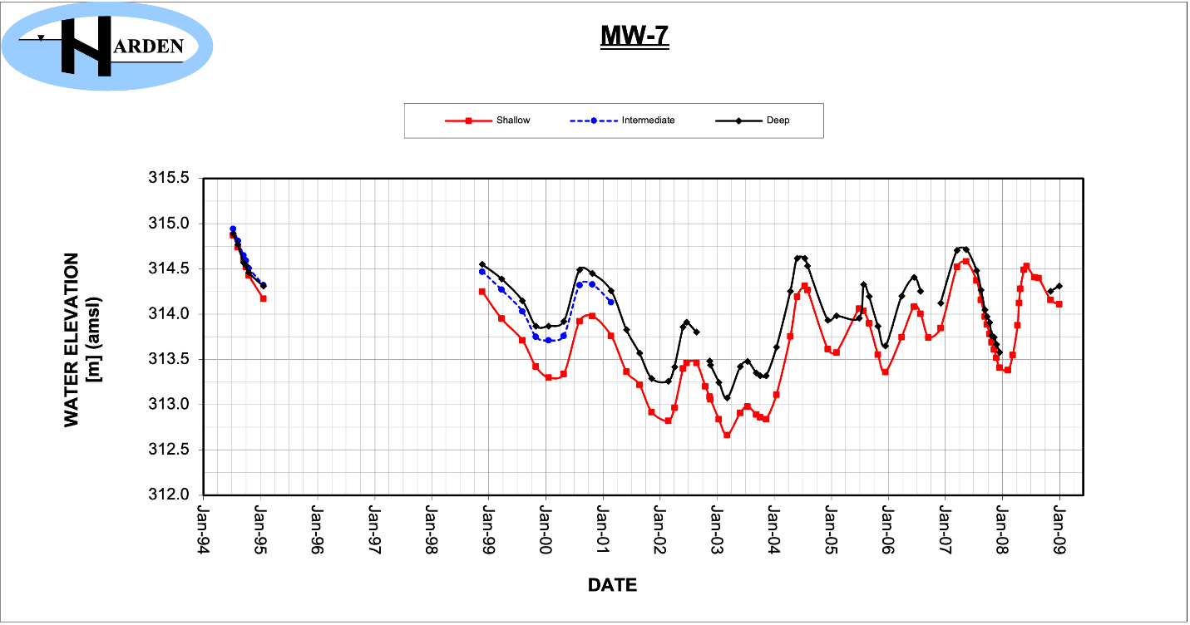**Figure A2.7.** January groundwater levels in the MW-7 well from 1994-2009 (Harden Environmental, n.d.a).

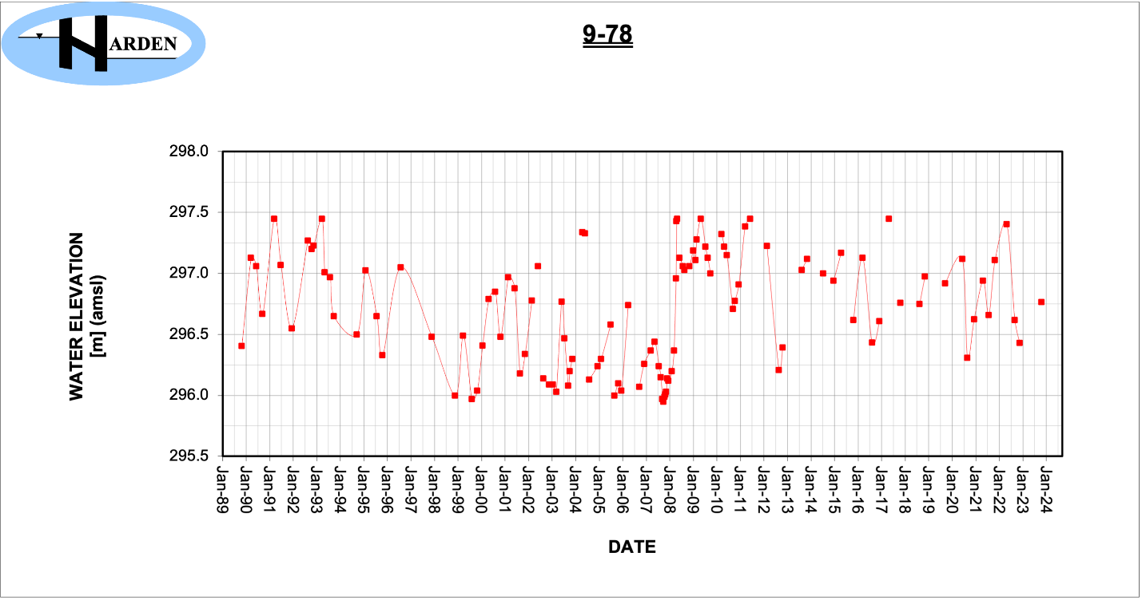**Figure A2.8.** January groundwater levels in the 9-78 well from 1989-2024 (Harden Environmental, n.d.a).

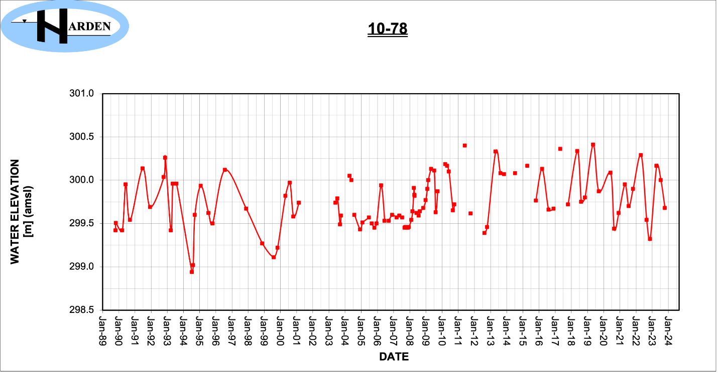**Figure A2.9.** January groundwater levels in the 10-78 well from 1989-2024 (Harden Environmental, n.d.a).

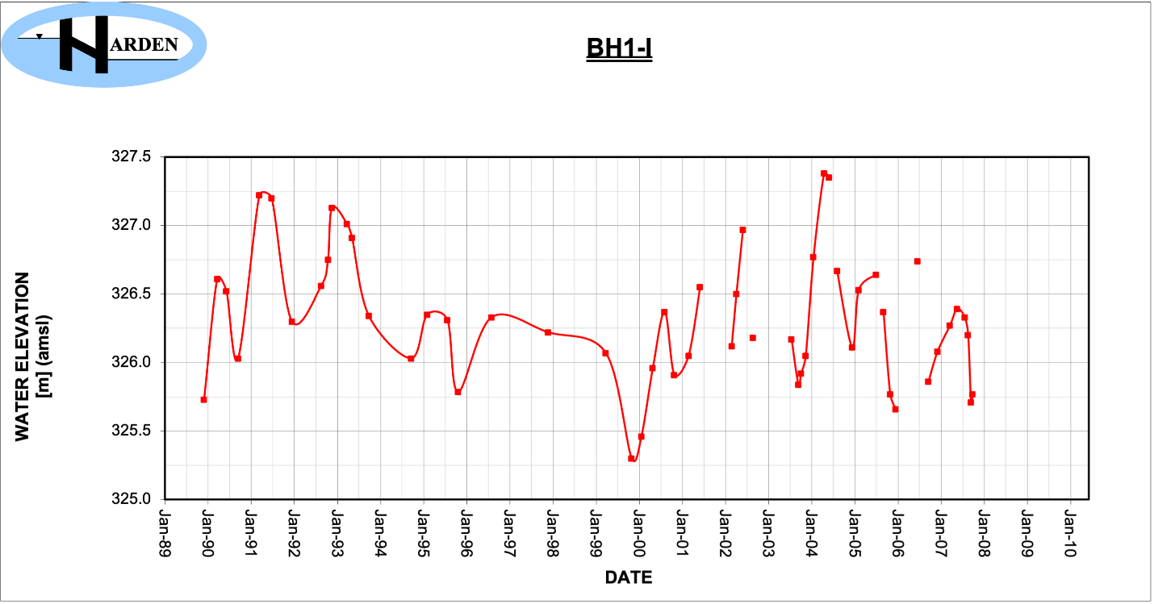**Figure A2.10.** January groundwater levels in the BH1-I well from 1989-2010 (Harden Environmental, n.d.a).

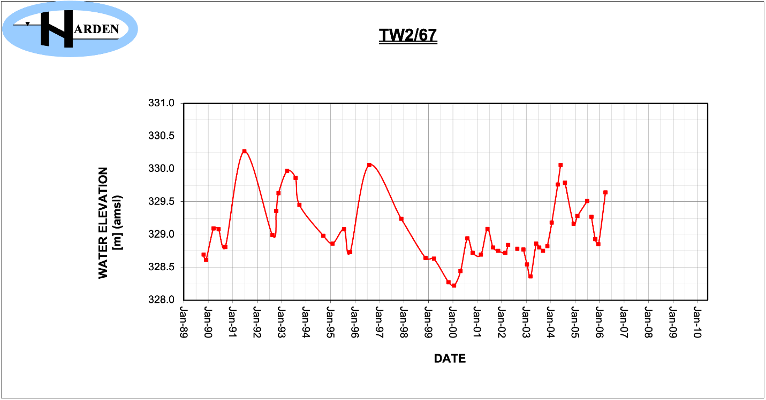**Figure A2.11.** January groundwater levels in the TW2/67 well from 1989-2010 (Harden Environmental, n.d.a).

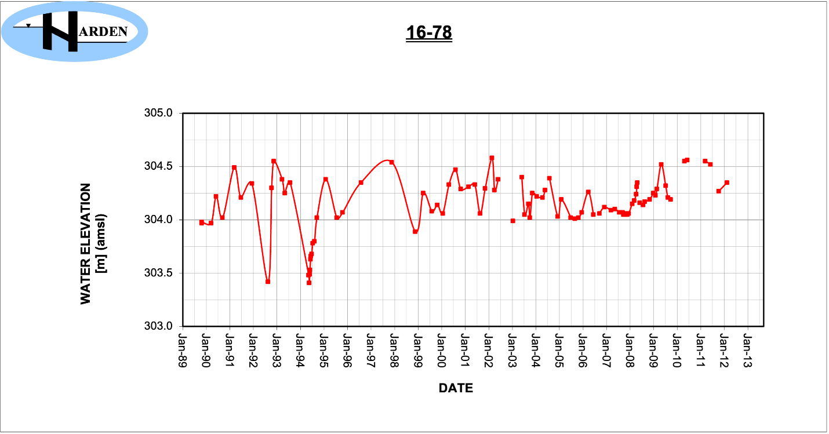**Figure A2.12.** January groundwater levels in the 16-78 well from 1989-2013 (Harden Environmental, n.d.a). 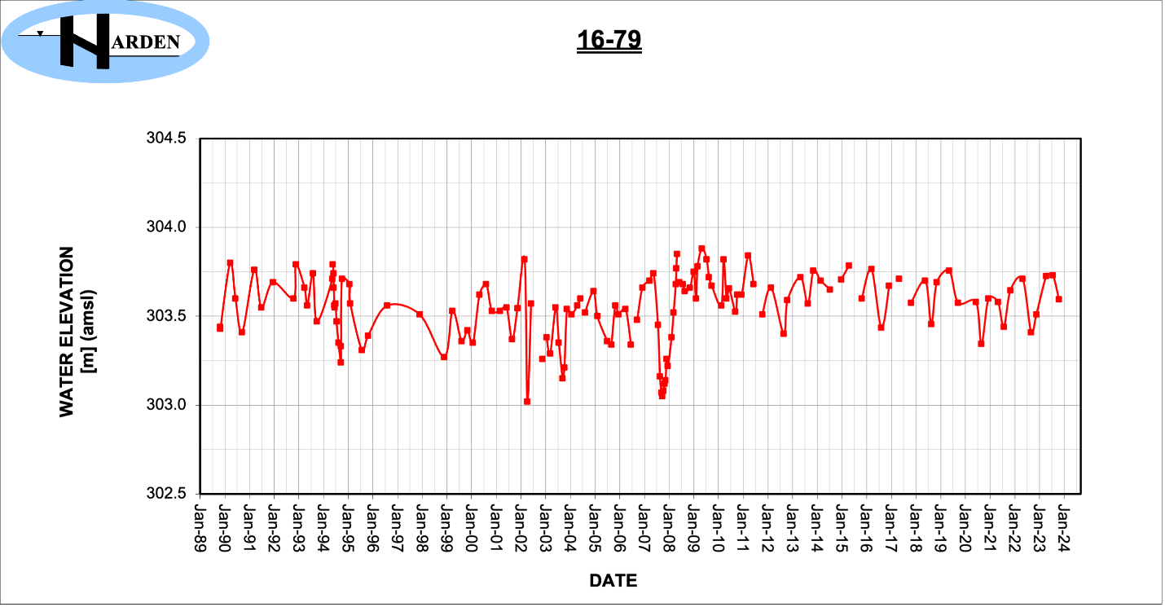**Figure A2.13.** January groundwater levels in the 16-79 well from 1989-2024 (Harden Environmental, n.d.a).

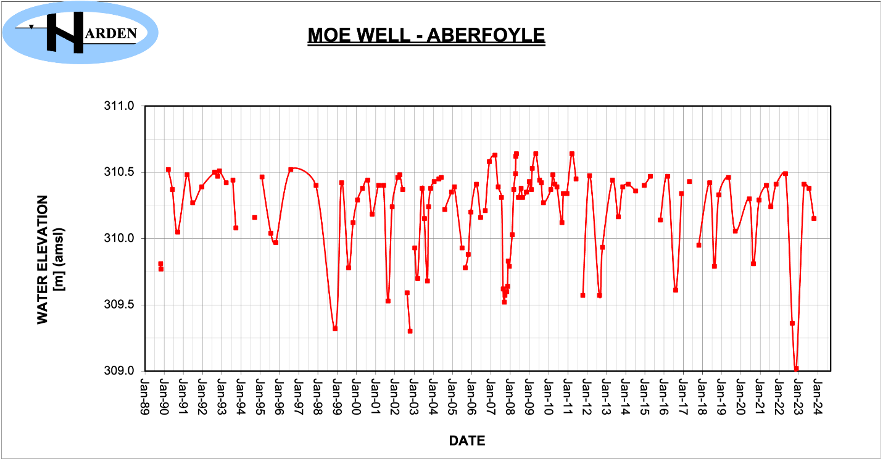**Figure A2.14.** January groundwater levels in the MOE Aberfoyle well from 1989-2024 (Harden Environmental, n.d.a).

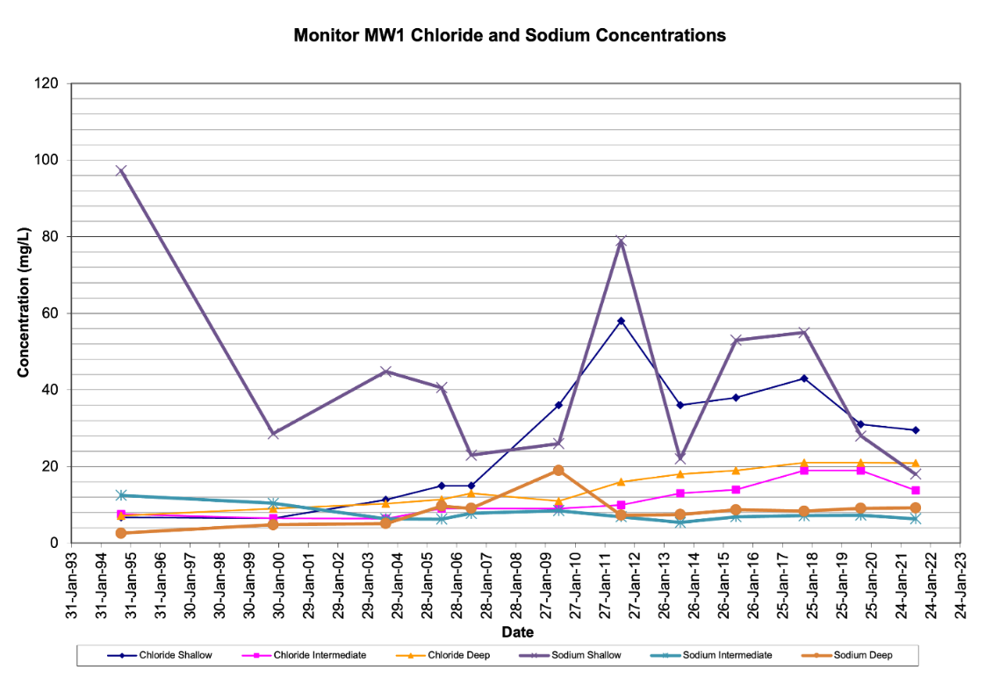

**Figure A3.1.** January groundwater water quality in the MW-1 Mill Creek Wetland well from 1993-2023 (Harden Environmental, n.d.b).

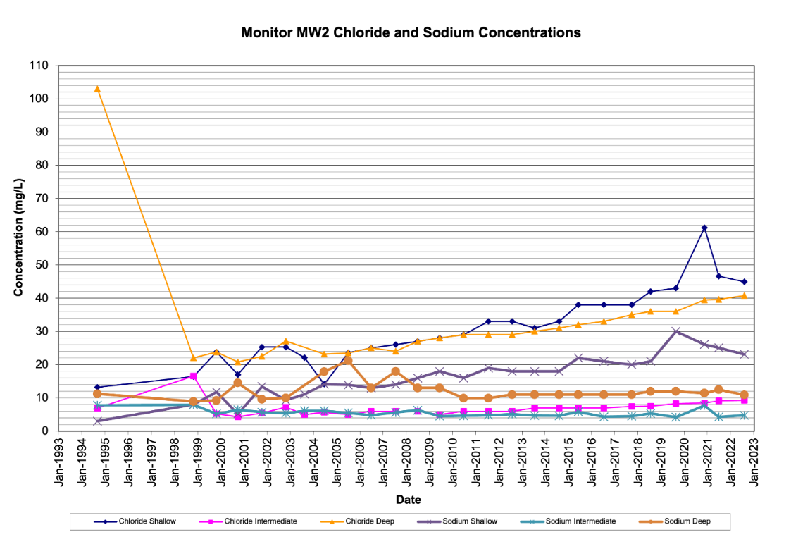

**Figure A3.2.** January groundwater water quality in the MW-2 Aberfoyle Outwash well from 1993-2023 (Harden Environmental, n.d.b).

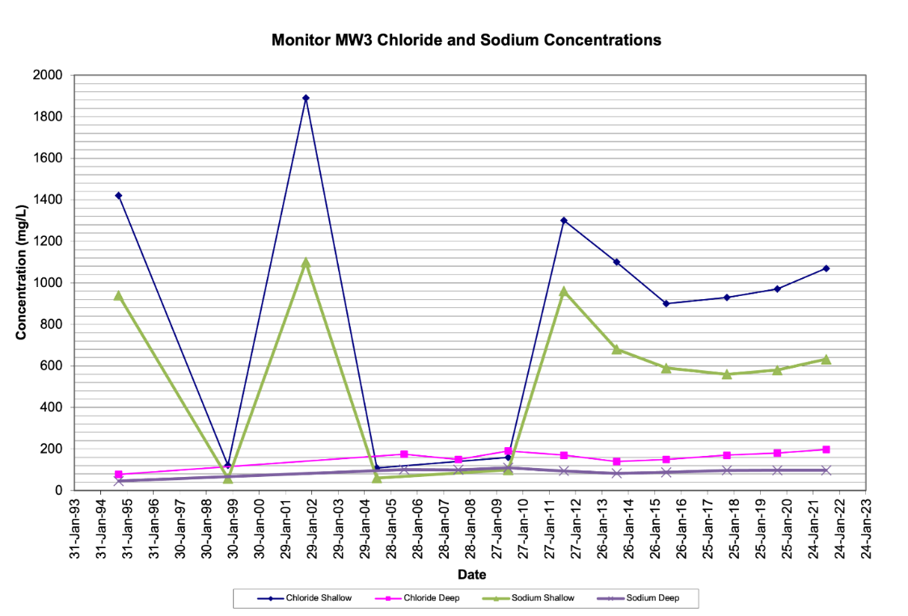

**Figure A3.3.** January groundwater water quality in the MW-3 Galt Moraine well from 1993-2023 (Harden Environmental, n.d.b).

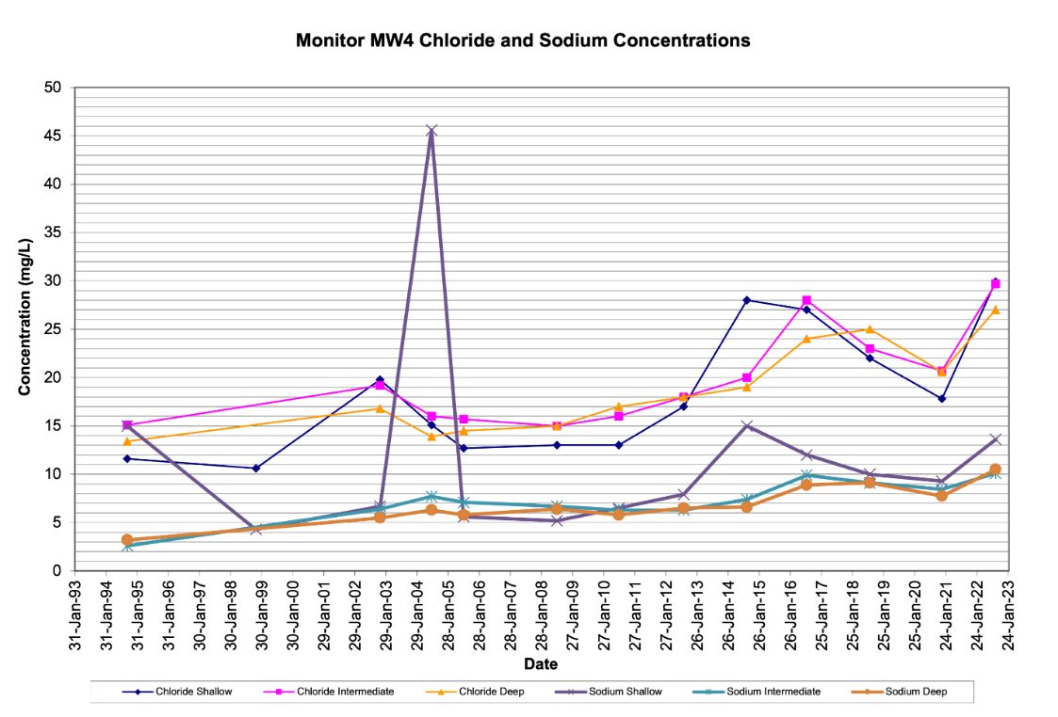

**Figure A3.4.** January groundwater water quality in the MW-4 Galt Moraine well from 1993-2023 (Harden Environmental, n.d.b).

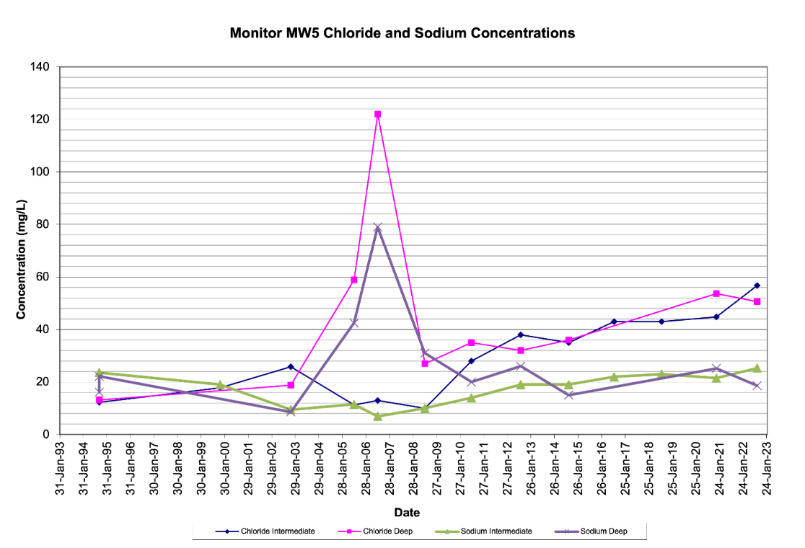

**Figure A3.5.** January groundwater water quality in the MW-5 Paris Moraine well from 1993-2023 (Harden Environmental, n.d.b).

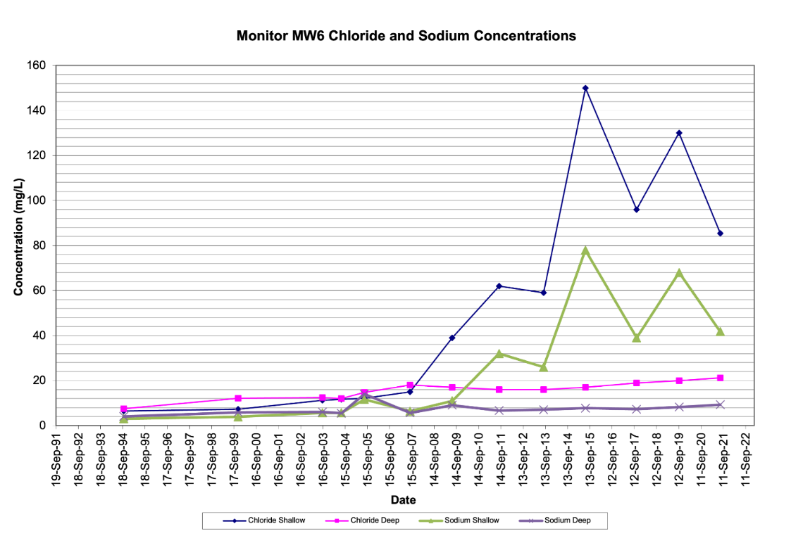

**Figure A3.6.** September groundwater water quality in the MW-6 Aberfoyle Outwash well from 1991-2022 (Harden Environmental, n.d.b).

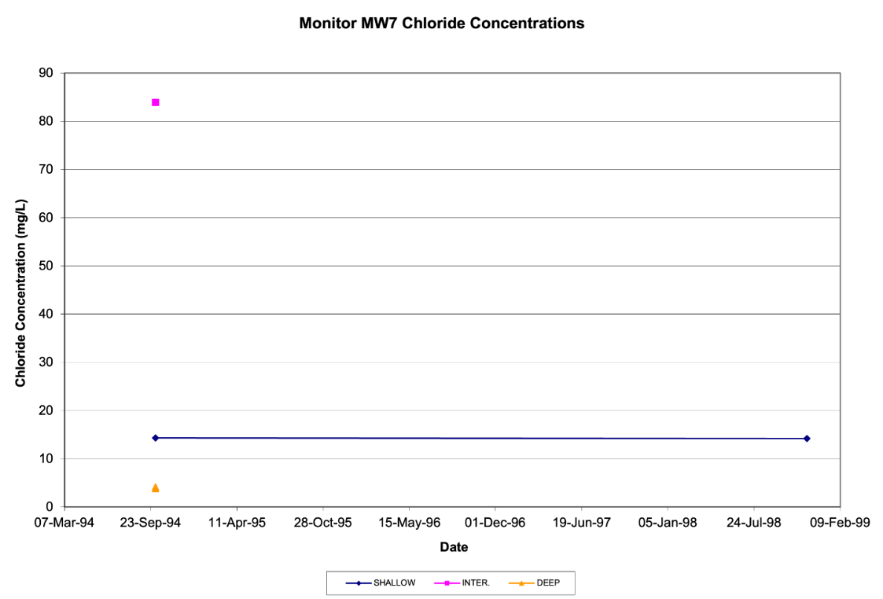

**Figure A3.7.** Select groundwater quality measurements in the MW-7 well from 1994-1999 (Harden Environmental, n.d.b).

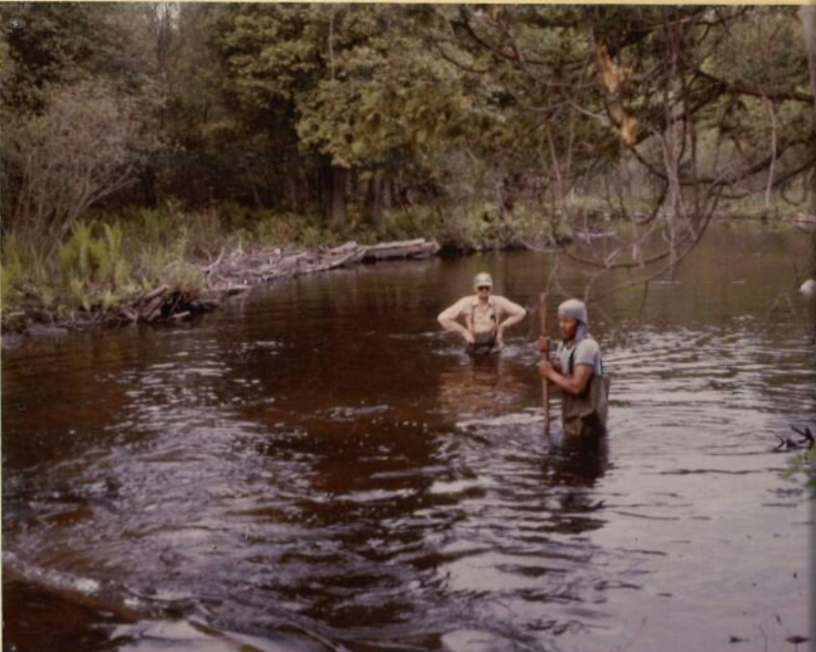

**Figure A3.1.** Community efforts in data collection, historical reference.

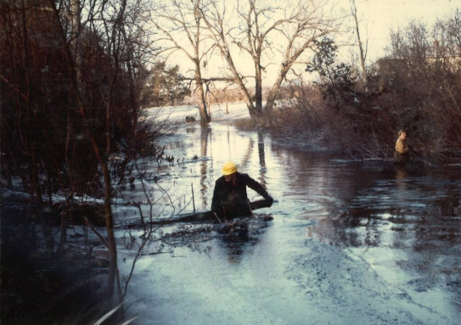

**Figure A3.2.** Community efforts in geomorphology and water flow rehabilitation, historical reference.

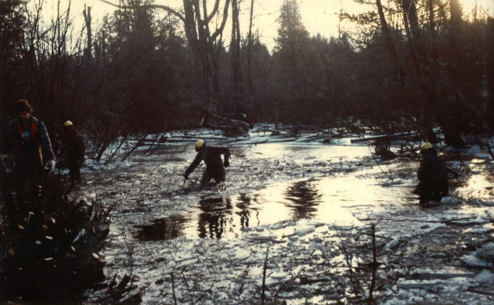

**Figure A3.3.** Community efforts in geomorphology and water flow rehabilitation, historical reference. Second photo.

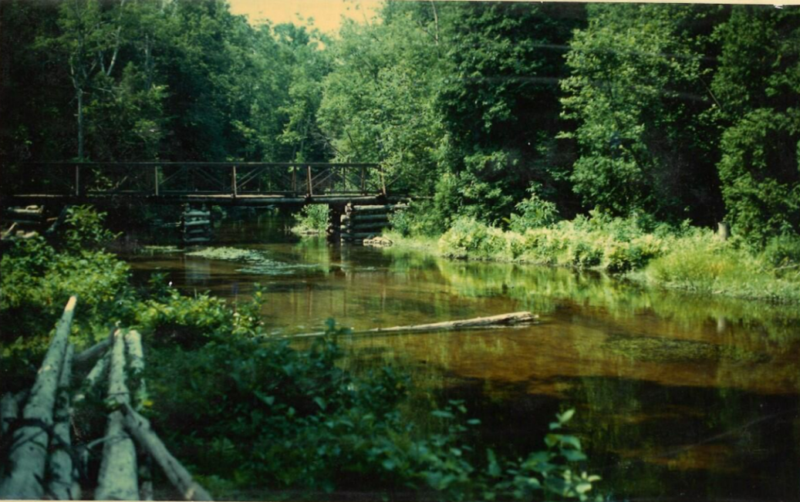

**Figure A4.1.** Historical restoration site on Mill Creek: Bridge.

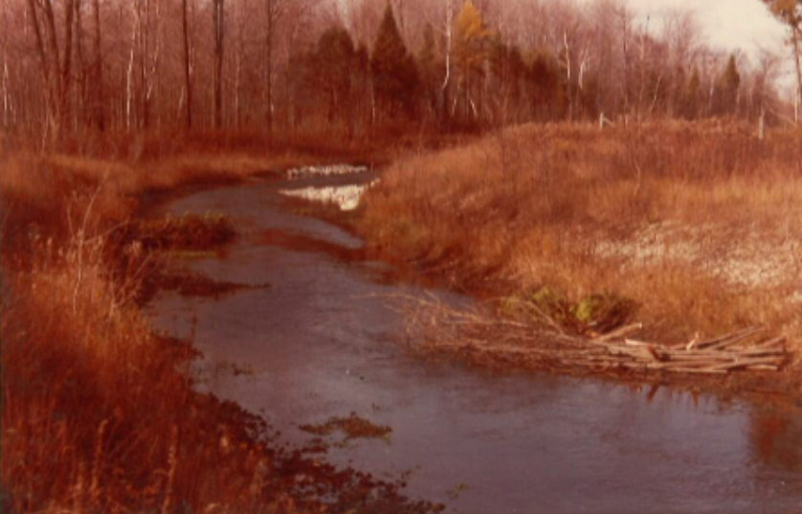

**Figure A4.2.** Mill Creek geomorphology, historical reference. Site-scale.

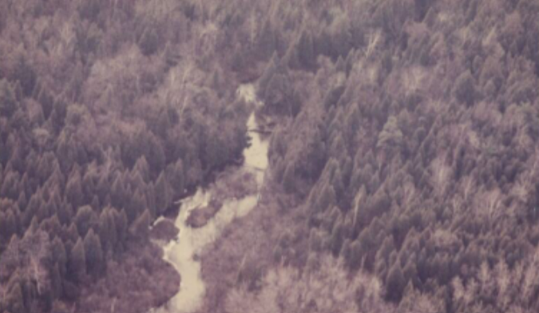

**Figure A4.3.** Mill Creek geomorphology, historical reference. Landscape-scale.

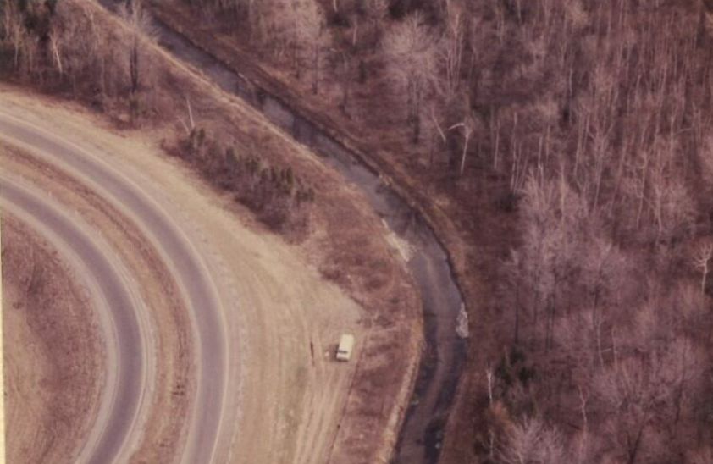

**Figure A4.4.** Mill Creek geomorphology and land-use, historical reference. Landscape-scale.

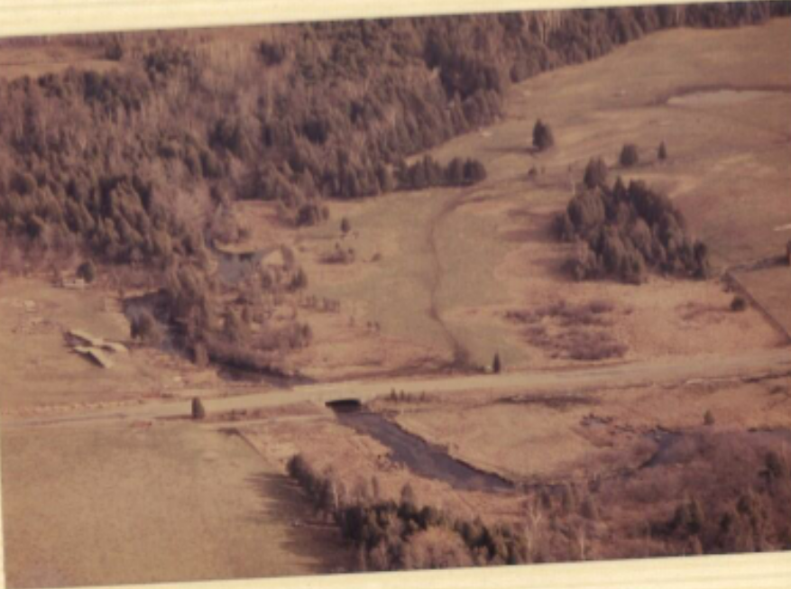

**Figure A4.5.** Mill Creek land-use, historical reference. Landscape-scale.

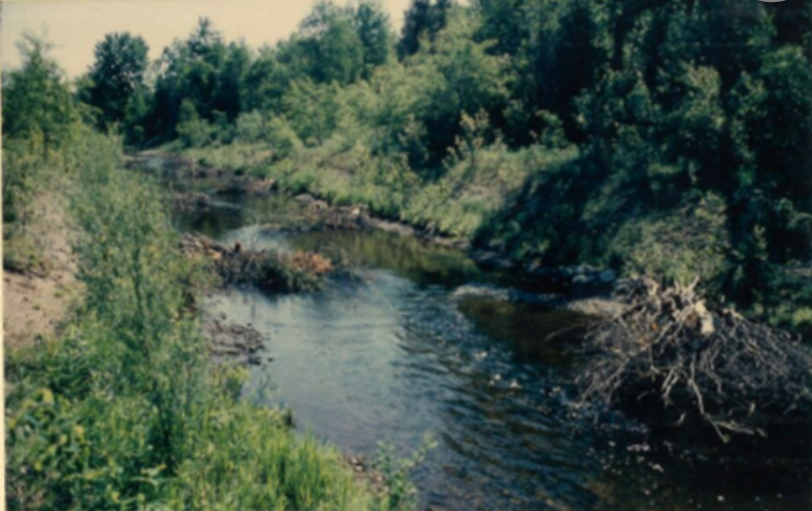

**Figure A4.6.** Mill Creek vegetation biodiversity, historical reference. Warmer seasons.

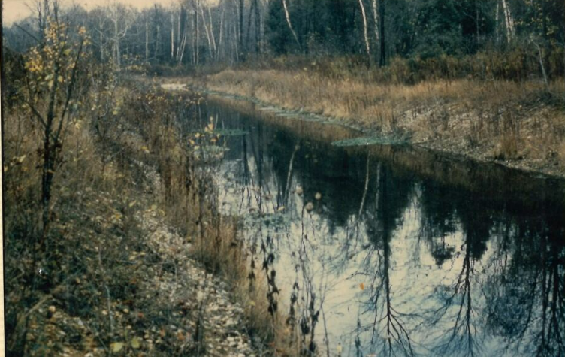

**Figure A4.7.** Mill Creek vegetation biodiversity, historical reference. Colder seasons.